Requisition – Close

Via Requester's Workbench (p.1-4)

Via Close Requisitions page (p.5-11)
- Main Menu > Purchasing > Requisitions > Requester's Workbench
- Your first time to use Requester's Workbench: Add a New Value
- Name your Workbench ID anything you wish. No spaces allowed.
- Click Add
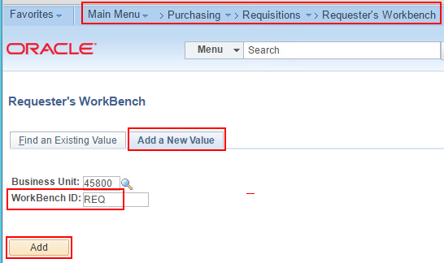
- Enter the Req ID of the Requisition you want to close in both fields. Click Search.
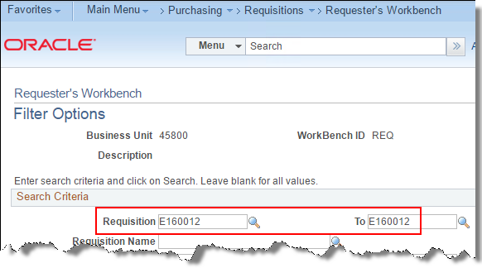

- Check the box and click Close. (Your first time to this page, enter a Description)
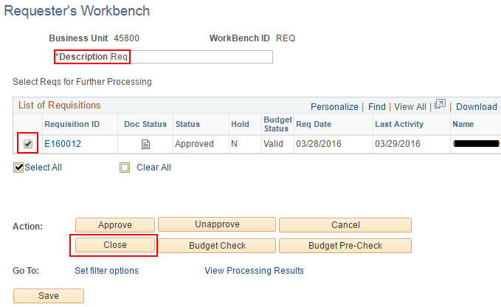
- If your Req displays under Not Qualified, click the Log button to see the reason.
If your Req displays under Qualified, click Yes to proceed.
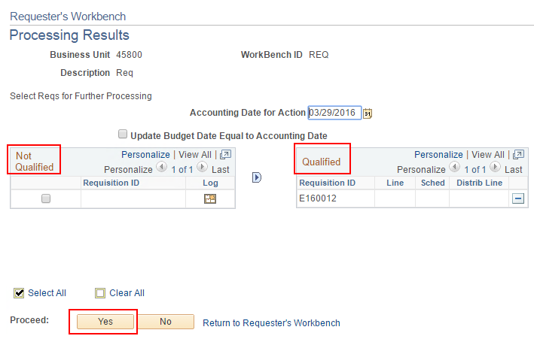
- Click Yes to continue.
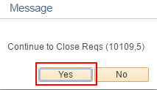
- Status becomes Complete, which means the req is closed.
- Click Budget Check.
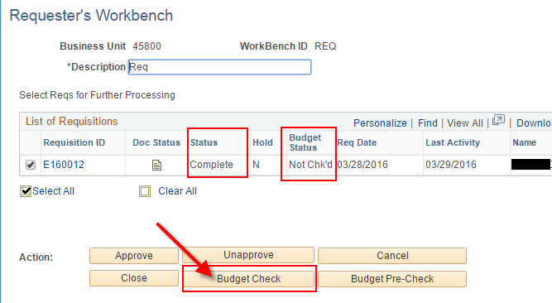
- Click Yes to proceed.
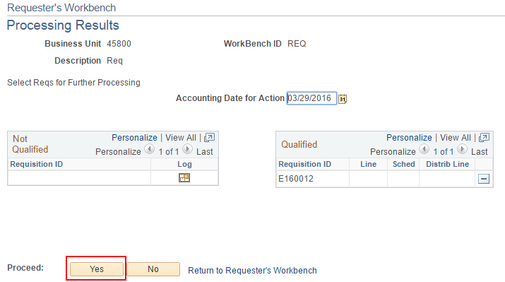
- Click Yes to continue.
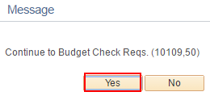
- Budget Status should become Valid.
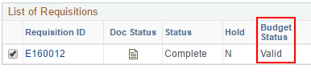
Req Close via Requester's Workbench is complete.

Closing a Requisition via the Close Requisitions page.
- Main Menu > Purchasing > Requisitions > Reconcile Requisitions > Close Requisitions
- Tab: Add a New Value (first time only; thereafter use Find an Existing Value)
- Create your own Run Control ID. No spaces allowed. Example: CLOSE_REQ
- Click Add.
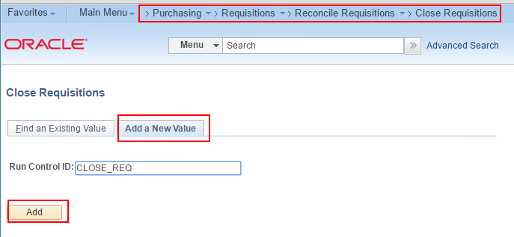
- Set 'Requisition Run Option' = 1 Document.
Enter your Business Unit and the Requisition ID you want to close.
Click Run.
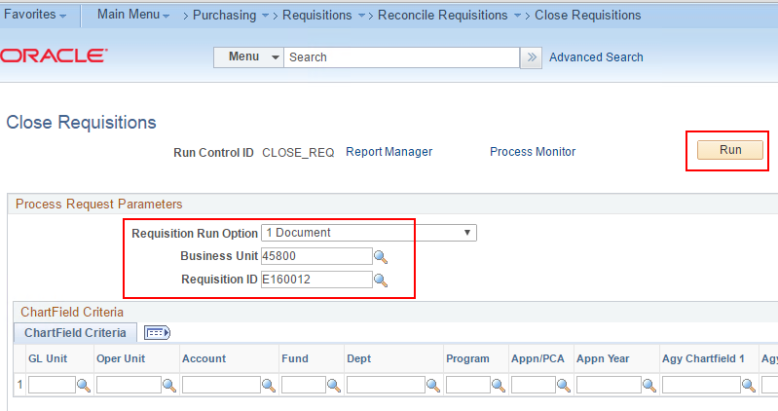
- Select Process Name "PO_REQRCON" and click OK.
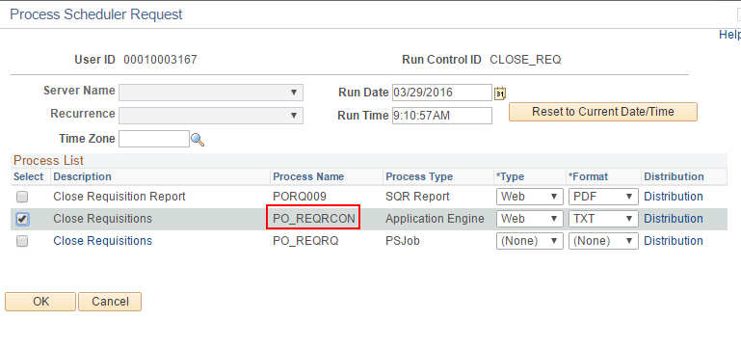
- Optional: You can click the 'Process Monitor' link to verify the process runs to a status of Success.
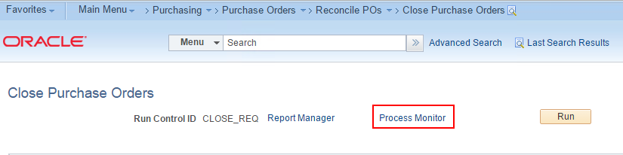

- Click the Refresh button every 5-10 seconds until the Run Status is Success. Then you can click the 'Go back to Close Requisitions' page if you need to close another Requisition. If not, go to the next step.
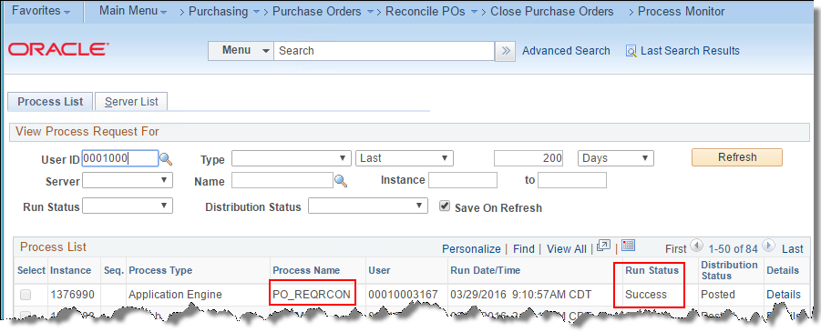


- Go Favorites > Manage Requisitions, or if you haven't added it to your Favorites menu yet, go to Main Menu > eProcurement > Manage Requisitions.
- Set Request State = Complete
- Blank out Date From and Requester fields. You may or may not need to enter the Req ID, depending on how many Closed/Complete requisitions are in your search results. 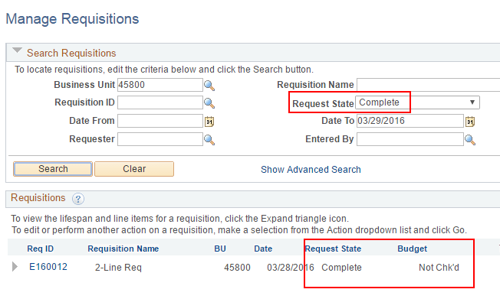
- Notice in the picture above the Budget status is 'Not Chk'd'. The Close process prepares the requisition for a final budget checking which will liquidate any remaining pre-encumbrances on the requisition.
- The requisition will be picked up by batch budget checking which runs several times a day.

- If you want to budget check the requisition immediately, navigate to Main Menu > Purchasing > Requisitions > Budget Check.
- The first time here you'll need to create your Run Control ID. Thereafter you can reuse the same Run Control ID by going to the Find an Existing Value tab.
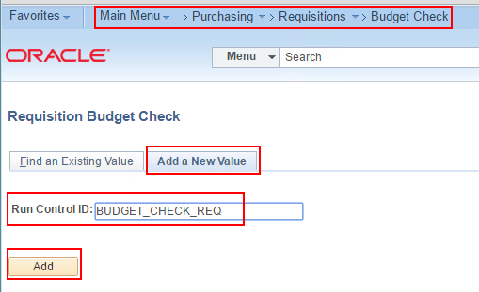
- Set the Process Frequency to Always Process.
- Enter any Description.
- Set Business Unit and Req ID to 'Value' and enter the fields that appear on the right.
- Click Run.
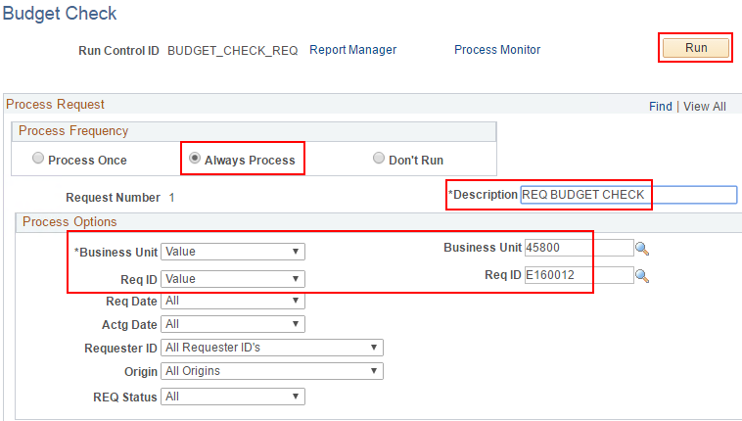
- Click OK on the Process Scheduler Request.
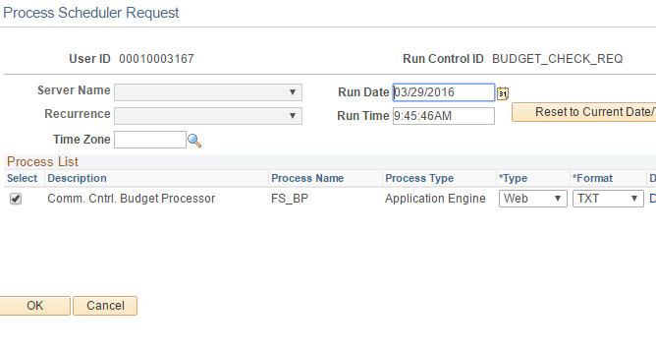

- Give it a minute to run, or check it on the Process Monitor. Then go back to Main Menu > eProcurement > Manage Requisitions.
- Search for the Requisition making sure to set Request State = Complete.
- Budget status should now be valid.
- Pre-encumbrance should be 0.00.
