Voucher Entry- Indigent Fee Transfer to CPA
- Main Menu > Accounts Payable > Vouchers > Add/Update > Regular Entry.
'Add a New Value'
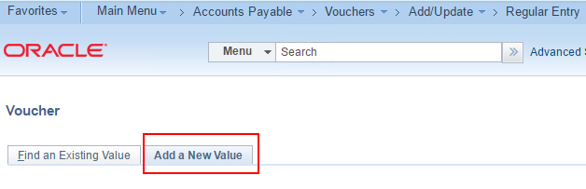
- Enter Supplier Name or Supplier Id, Invoice Number, Invoice Date, and Gross Amount
and click Add.
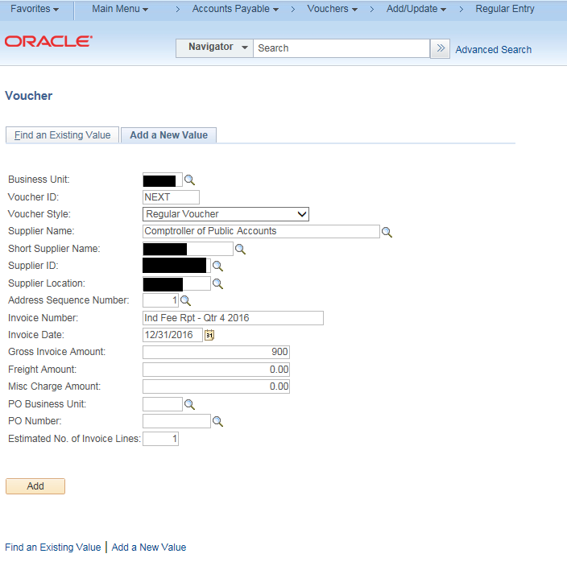
- Verify that the value in the Payment Type field on the voucher header is “T”
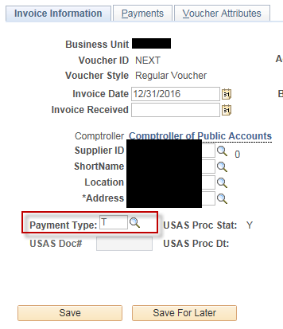
- On the “Invoice Information” tab, scroll down to the “Invoice Lines” section.
In the Invoice Lines Section:
- Enter the Description
- Update the Line Amount for this specific transaction
- Enter the appropriate value in the RTI field
- Enter the Invoice Description
In the Distribution Lines section:
- Verify the Merchandise Amt matches the voucher Line Amount
- On the GL Chart tab, Enter the appropriate values in the GL Chartfields, i.e., the GL Coding Block (this may vary by agency)
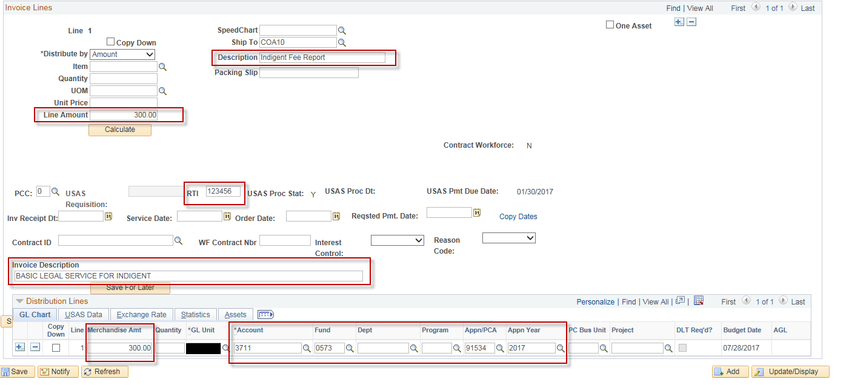

- Click in the Copy Down checkbox in the Invoice Lines section.
Click the “+” to add new voucher lines
Enter the number of lines you wish to add, in this example we entered 2.
Click OK.
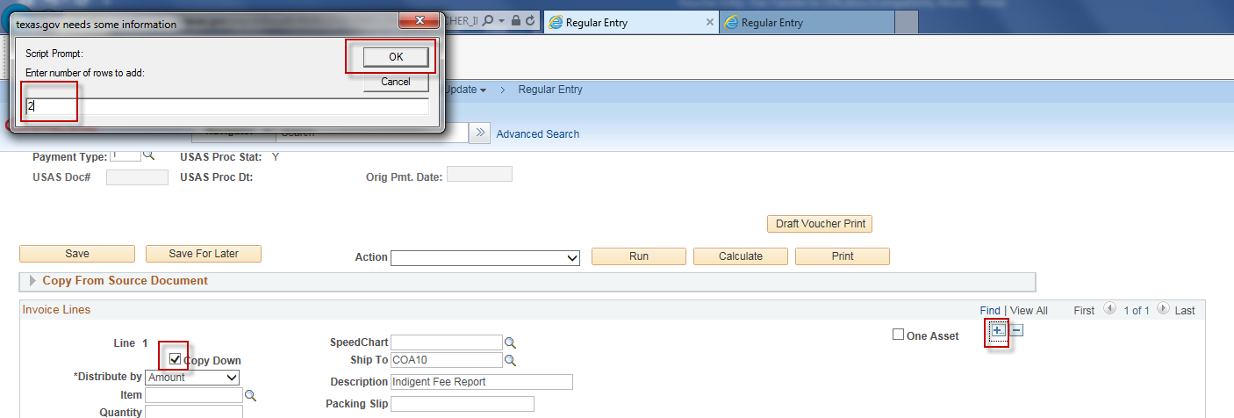
- In the Invoice Lines section, click on the Copy Dates hyperlink.
Enter the Invoice Receipt Date (this can be the last date of the service period)
Enter the Service Date (this can be the last date of the service period)
Enter the Requested Pmt. Date (Optional)
Click “OK”
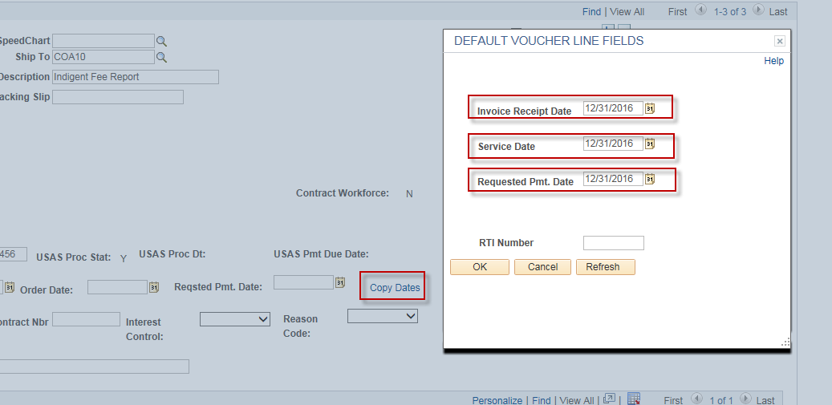

- On the voucher Line 2,
- Update the value in the Line Amount to the appropriate amount
- Enter the appropriate value in the RTI field
- Enter the appropriate description in the Invoice Description field
In the Distribution Lines section:
- Verify the Merchandise Amt matches the voucher Line Amount
- On the GL Chart tab, Enter the appropriate values in the GL Chartfields, i.e., the GL Coding Block (this may vary by agency)
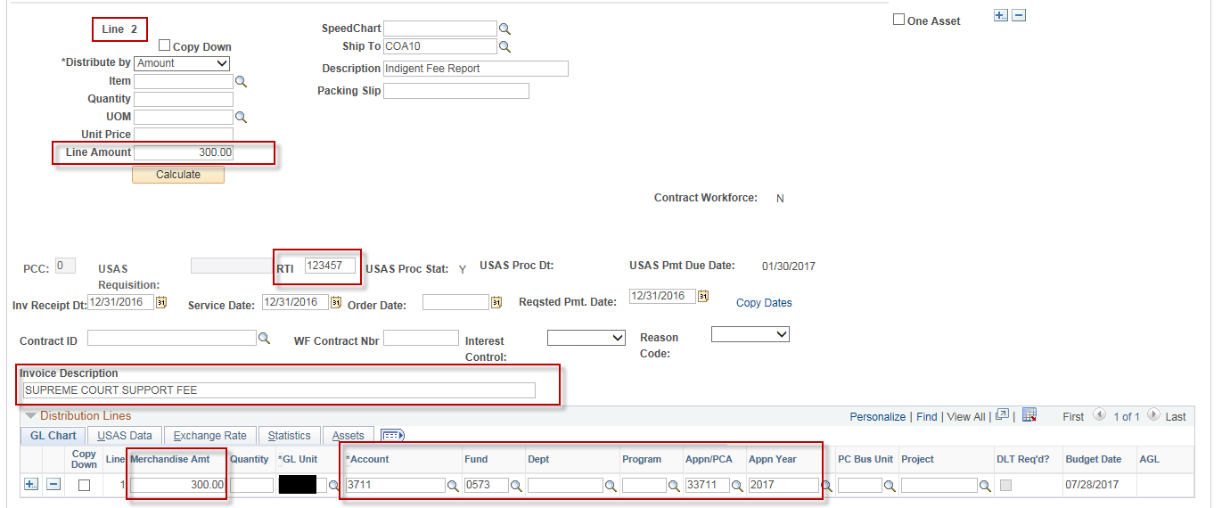

- On the voucher Line 3,
- Update the value in the Line Amount to the appropriate amount
- Enter the appropriate value in the RTI field
- Enter the appropriate description in the Invoice Description field
In the Distribution Lines section:
- Verify the Merchandise Amt matches the voucher Line Amount
- On the GL Chart tab, Enter the appropriate values in the GL Chartfields, i.e., the GL Coding Block (this may vary by agency)
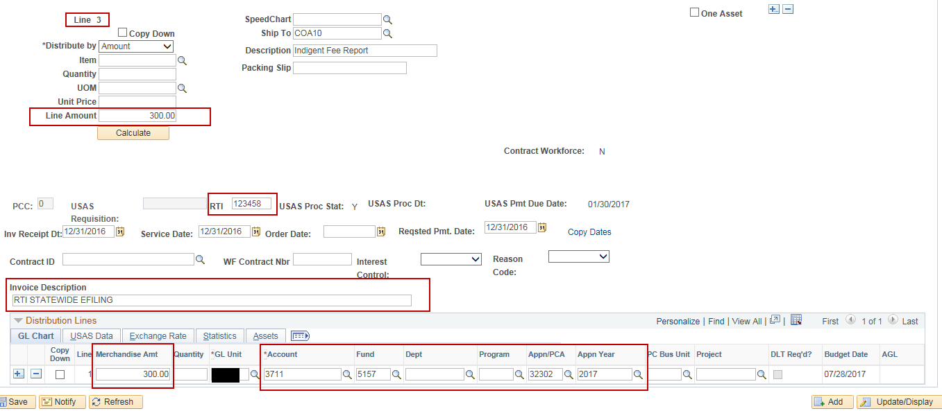
- On the voucher header, verify that the value in the Total box matches the value in the Line Total and the Difference is 0. If not, update the Total box to match the Line Total and click on the Calculate button.
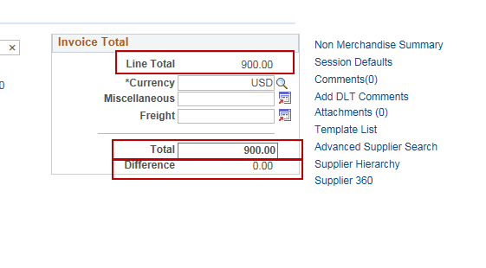
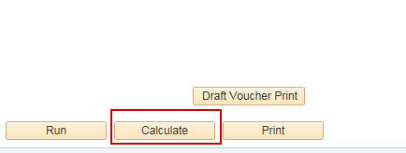

- On the voucher header, click on the Add DLT Comments hyperlink
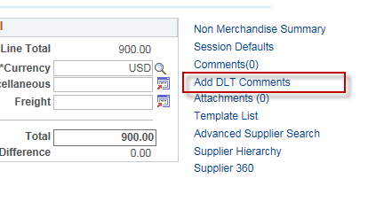

Click on the Use Standard Comments hyperlink
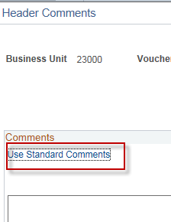

Select “DLT” in the Comment Type Box
Select the applicable Comment ID (the comment Id and text may vary by agency – for this specific example we combined 3 separate DLT comments into one DLT comment so that they can all 3 be copied into the voucher at once.)
Click “OK”
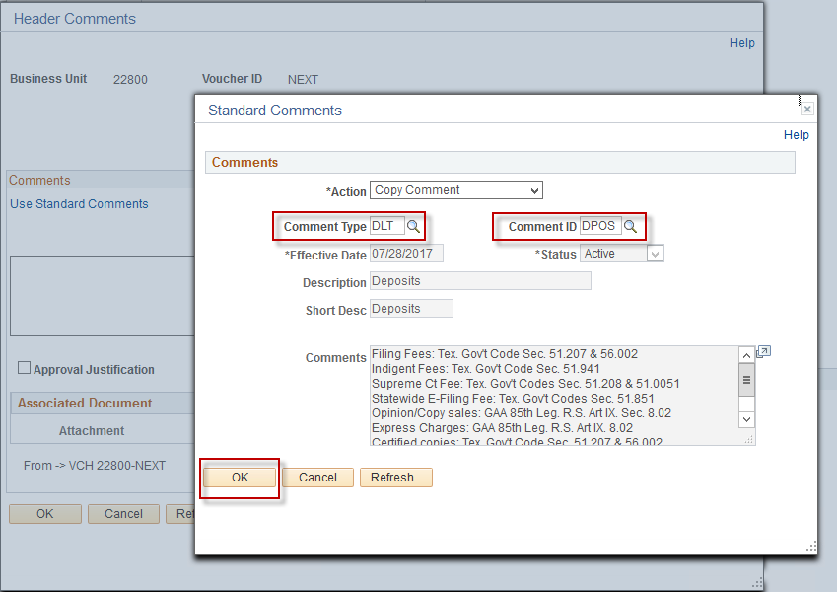

Verify your comment text was copied and that both DLT Comment Checkboxes are checked on
Click “OK”
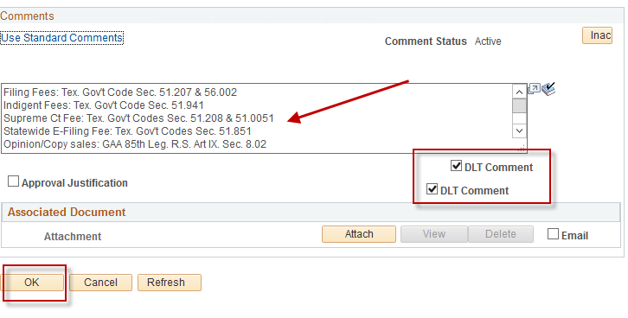

- On the “Voucher Attributes” tab, verify that the value in the “Template” field is the correct value and correct TCode is displayed
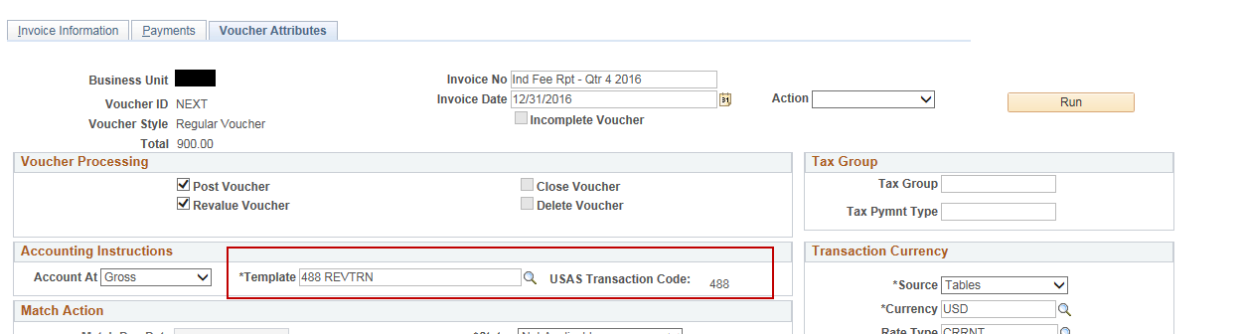

- Click “Save”
- On the “Invoice Information” tab, Select “Budget Checking” in the 'Action' dropdown list and click Run.
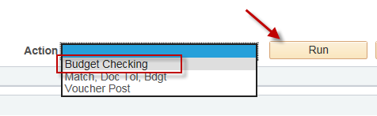

- Click the Refresh button to determine when the process has completed.
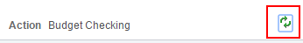
- When the “Budget Checking” process has completed, go to the Summary page to verify the voucher's Budget status.
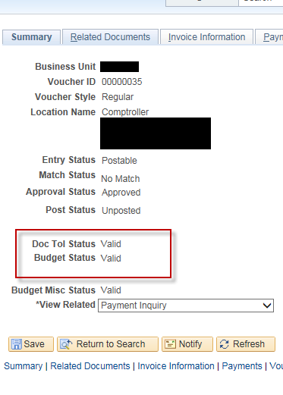
NOTE: The Voucher must be posted before it can be journal generated and sent to USAS.

