Supplier- Default ITV Template and Payment Type T
- Suppliers > Supplier Information > Add/Update > Supplier
- Tab: Find an Existing Value
Enter: SetID, and one or more Search Parameters such as all or part of Supplier Name or Supplier Id
Select: Correct History
Click: Search
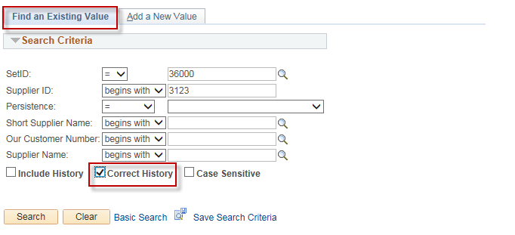

- Select your supplier from the Search Results list by clicking on it:
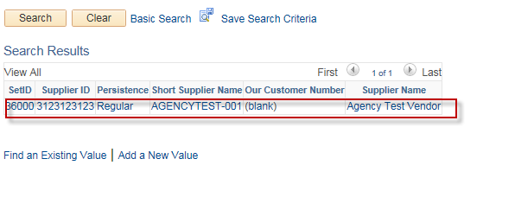

- Tab: Location
Action: For EACH applicable Location:
Click: Procurement hyperlink
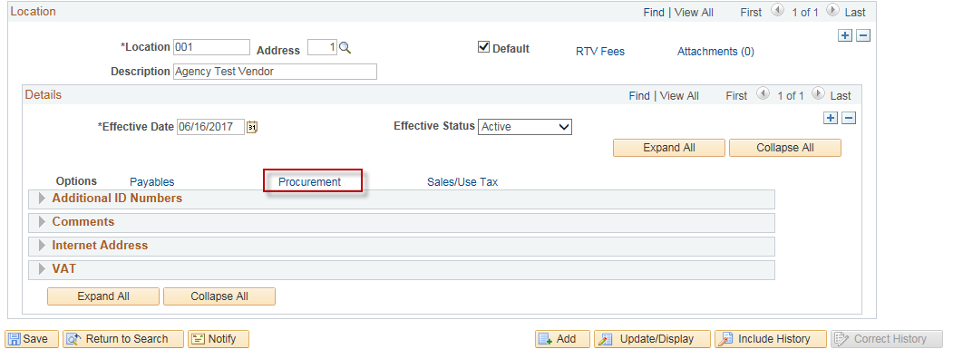

Scroll: Scroll down to “Additional Procurement Options” section and click the triangle to expand that section
Select: “Specifiy at this Level” in the “Accounting Options” drop down box
Select : “ITV DOC T” in the “Accounting Template” box.
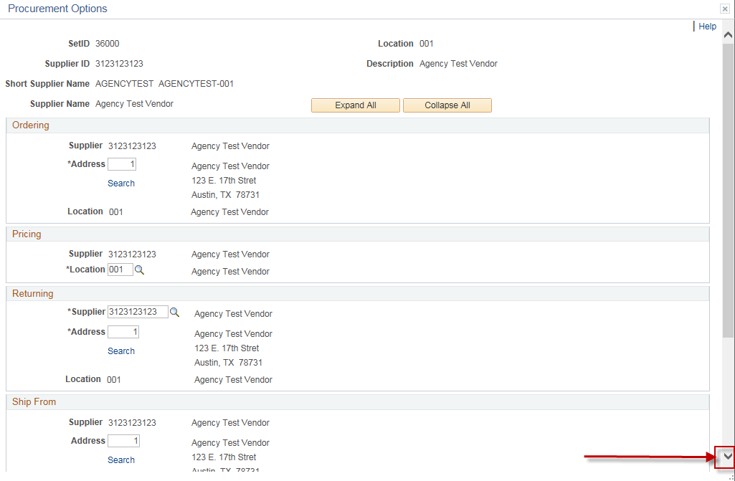
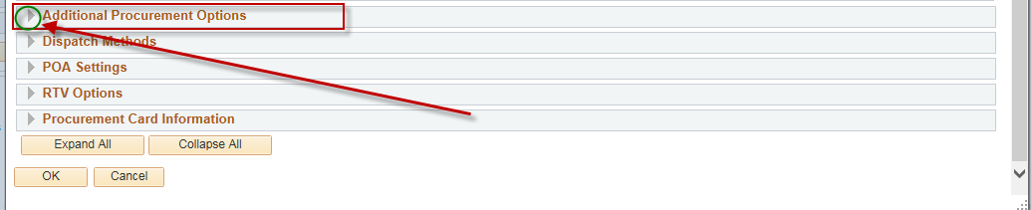
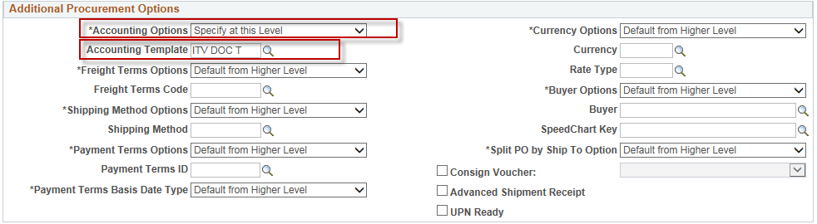
Click: Ok

- Tab: TINS Information
Select: Payment Type “T” for EACH Applicable Location
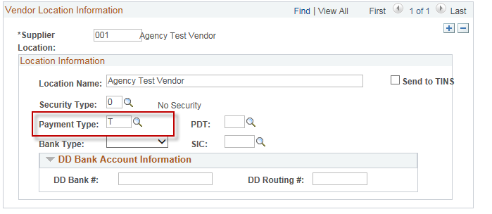
Click: Save

