Asset Retirement
- Navigation: Main Menu > Asset Management > Asset Transactions > Asset Disposal > Retire/Reinstate Asset
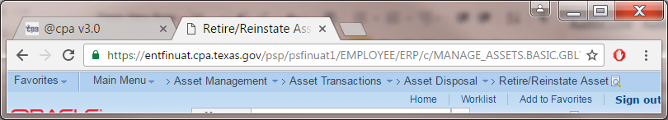
- Enter: Business Unit, asset ID to be retired, then Search. The Retire Assets page is displayed.
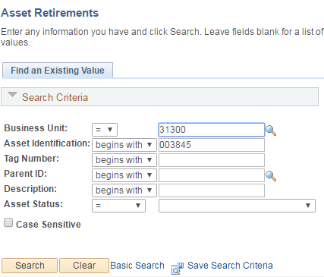

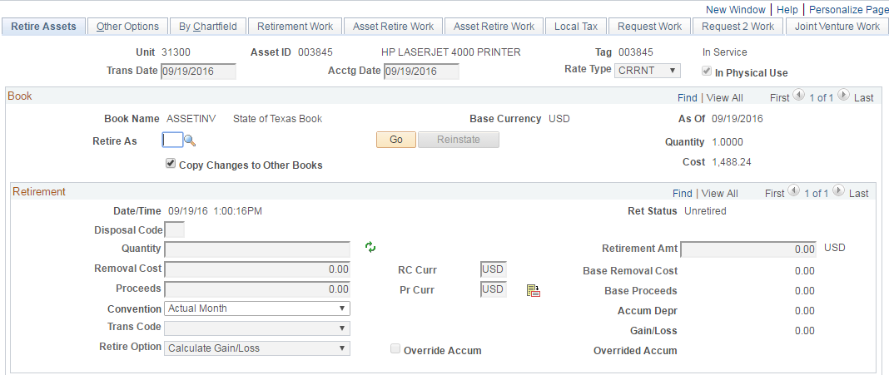

- Click Retire As lookup icon to select an appropriate disposal method.
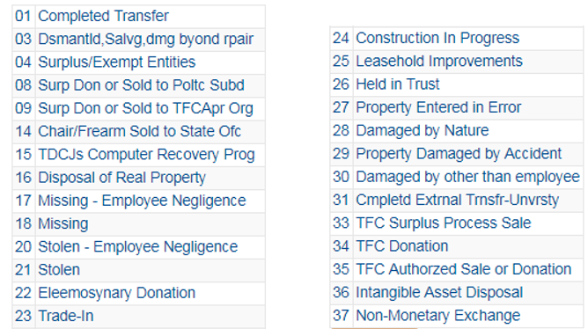

There are restrictions and rules on using certain DM. For example, DM 08, 09 and 15 can only be used in CAPPS when asset is in DM status 5C (Pending Agency Disposal) in SPA. DM14 can only be used for assets with class codes 103, 106 and 107. Please refer to SPA user manual for detail.

- Once a disposal method is selected such as DM 21, click GO button.

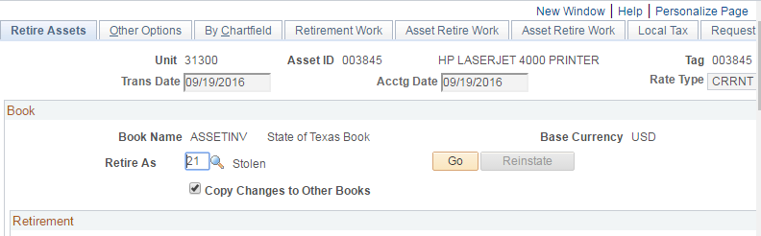

An alert message appears, click the OK button. Another message pops up asking to fill out the police report. Click OK button again.

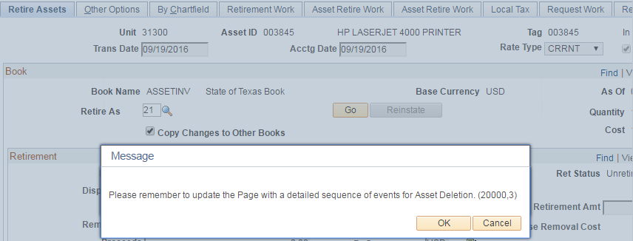
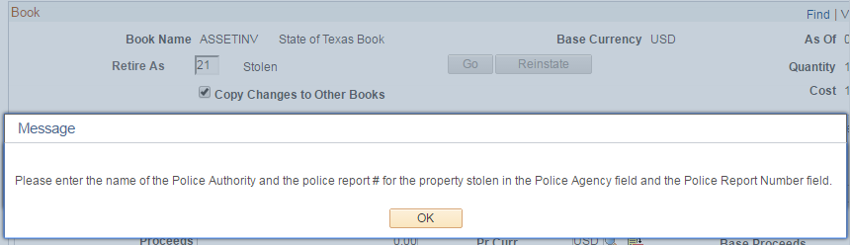

- Fields Police Agency, Police Report Number, Disposal Information and the Employee Negligence checkbox are displayed. Enter values in the corresponding fields. If there is any proceed from the sale, enter the amount.
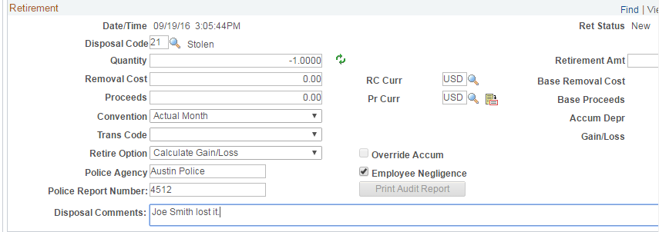
- Click the Save button. If you don’t enter any proceeds, a warning message will appear. Click OK to save the transaction.
