ERS/CAPPS Reconciliation Report
The ERS/CAPPS Reconciliation Report is used to compare employee data in ERS (using ERS monthly snapshot file) with the data in CAPPS. This report is a tool for benefit coordinators to catch any situations that were missed on the daily interface/loads and take the necessary steps to correctly process the employee’s benefits. The purpose of the report is the keep both systems in sync as much as possible.
The ERS 100% Snapshot file is loaded on the 10th of every month and the report can be run after the file has successfully processed. This file will have all employees for CAPPS Central Agencies and their ERS elections as of the end of the prior month (of the file being processed).
The following screen shots will assist the user in maximizing the use of the reconciliation report.
- Navigation: Main Menu>CAPPS Interfaces>Benefits>Reports>ERS/CAPPS Insurance Recon
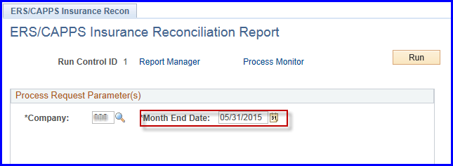
Use the end of the prior month for the run control “Month End Date”
(you can run the report for the up to 2 months prior to current month)

- This process creates 2 reports so when extracting the reports from the process monitor users will click on the Process Name:
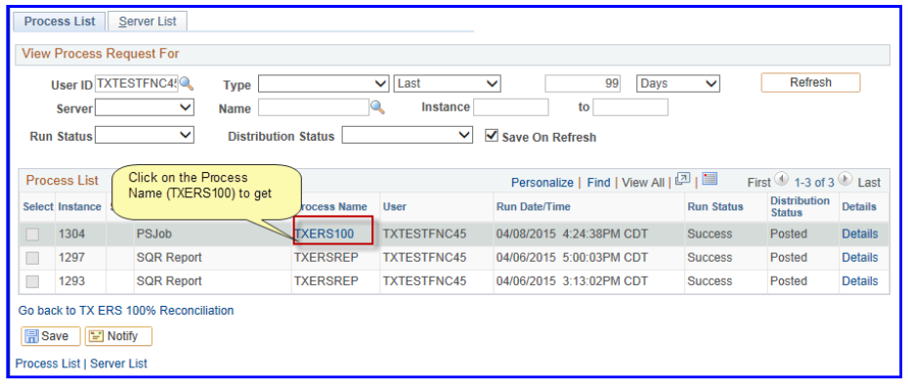
- Then the 1st report and/or 2nd report:
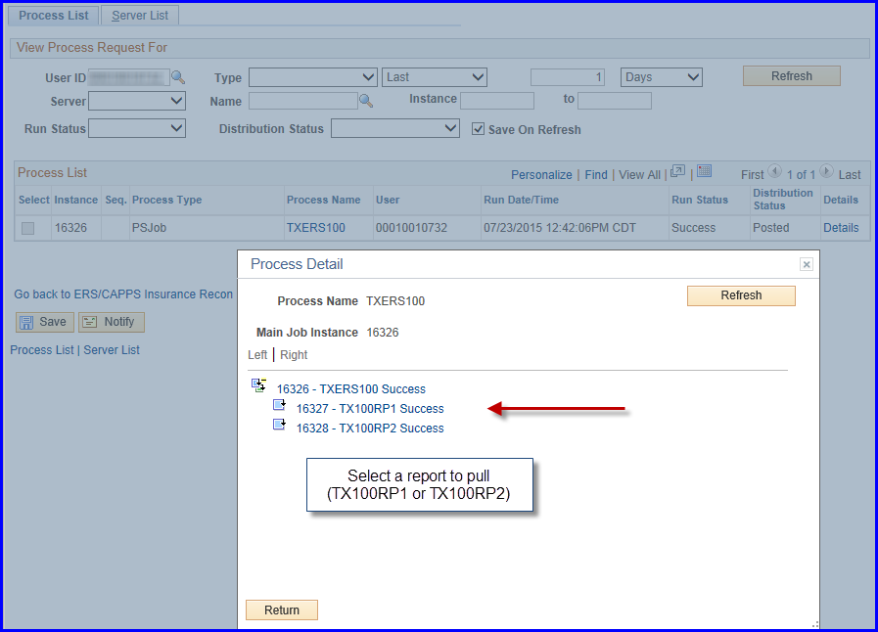

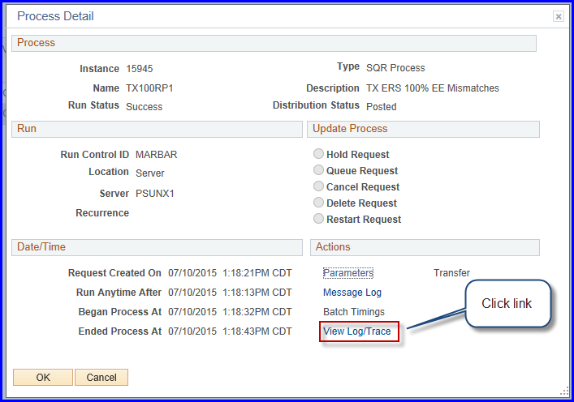
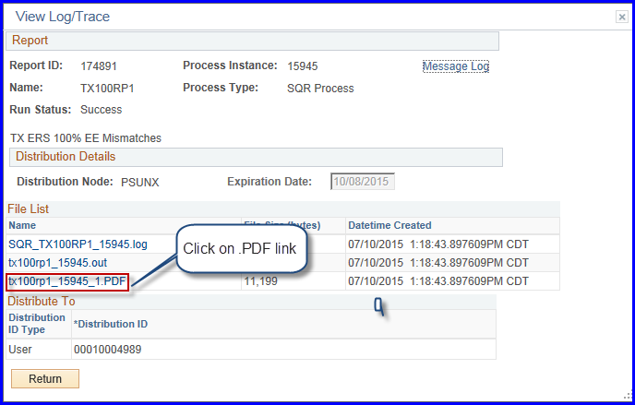

Then Report 1 will display: 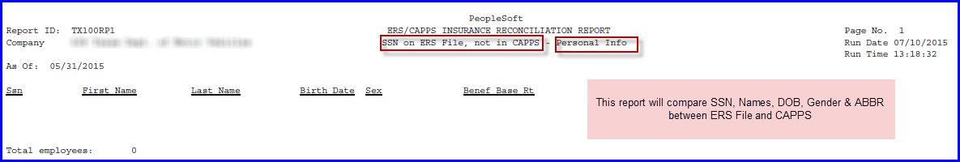

Report 1

Personal Info on ERS <> CAPPS

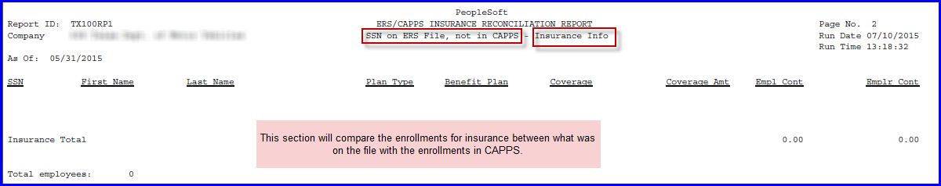
Insurance Info on ERS<> CAPPS
FLEX Info on ERS <> CAPPS
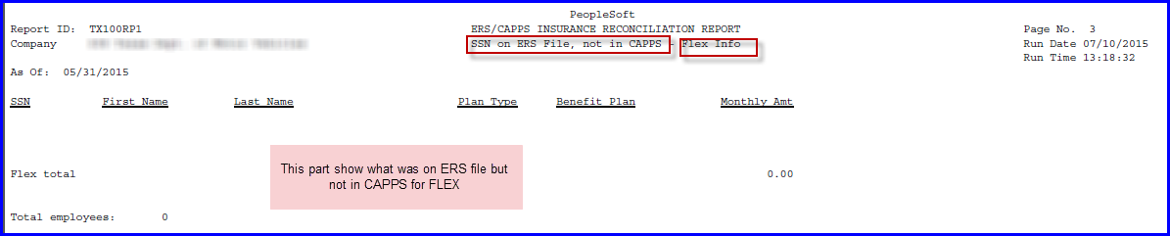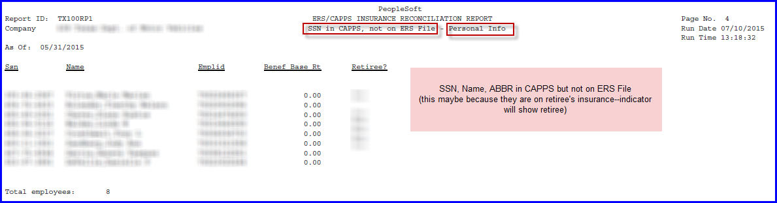
Personal Info in CAPPS not on ERS File
If the retiree indicator is “Yes”, the employee may have enrolled in retiree benefits (they will continue to show on this file). Other employees should be analyzed to determine appropriate actions.
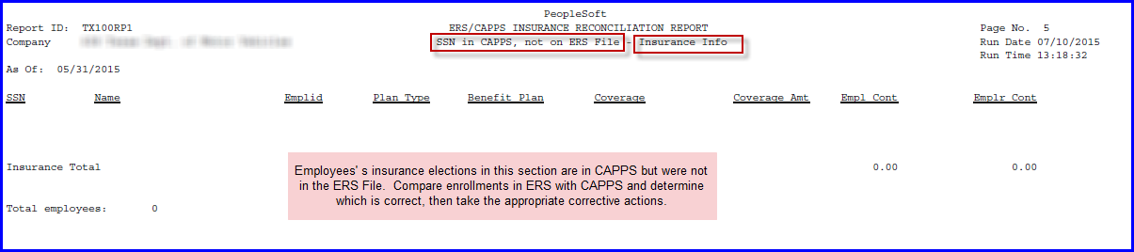

Report 1

Insurance Info in CAPPS not on ERS File
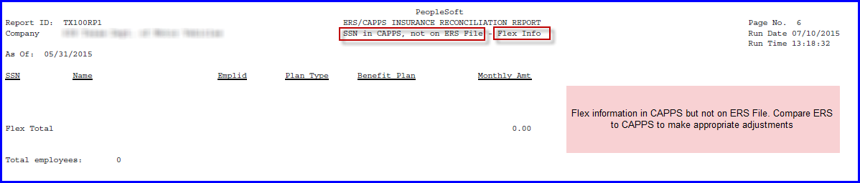
Personal Info on ERS file, but terminated in CAPPS
FLEX Info in CAPPS not on ERS File
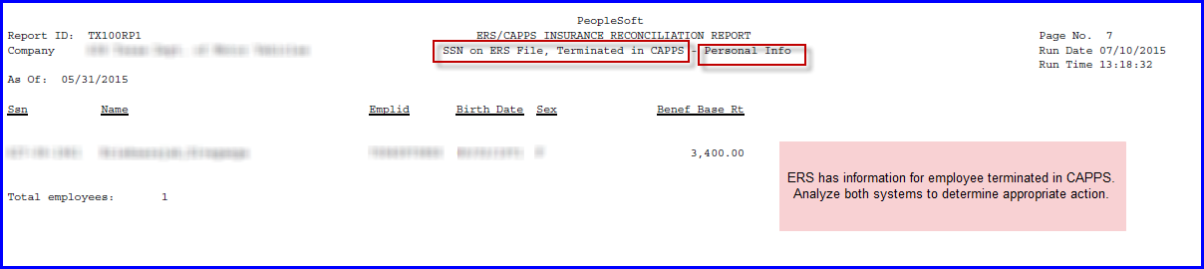
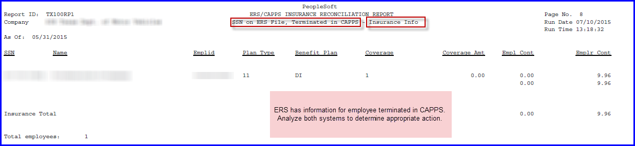
Insurance Info on ERS file, but terminated in CAPPS
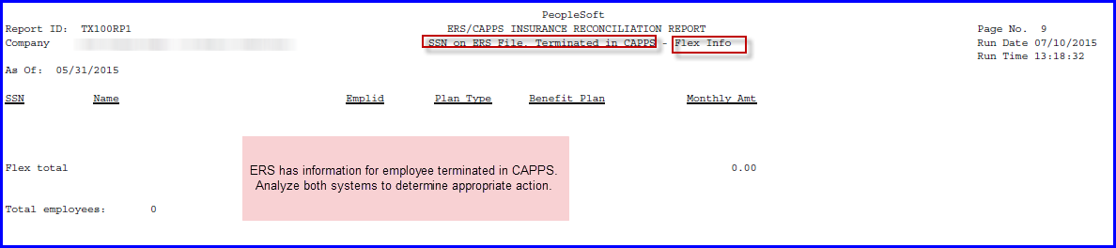
Flex Info on ERS file, but terminated in CAPPS

The second report of the reconcilation compares and matches employee details and will print the discrepancies for the user to perform further analysis and make the appropriate corrections.
Compares personal information and shows what ERS has on the file vs what CAPPS has in the system when there is a difference
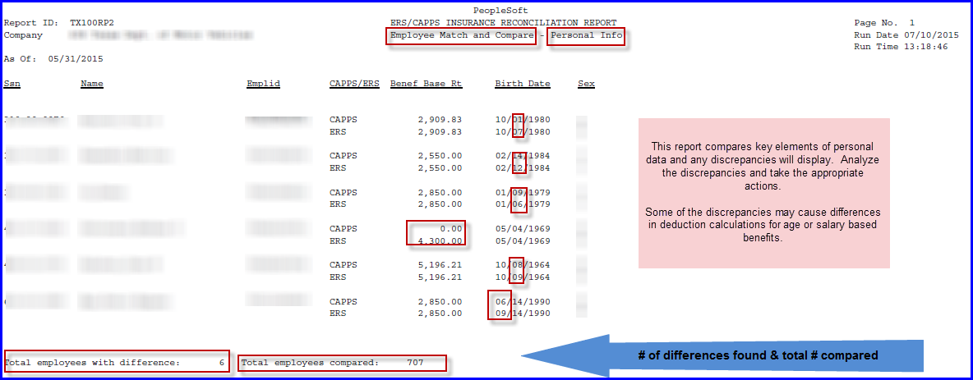

Report 2

NOTE: Benefit Base Rt (ERS Insurance Salary) should be calculated to an annual salary for CAPPS (as of 9/1 of enrollment year or hire date)
(DO NOT use monthly salary amounts)
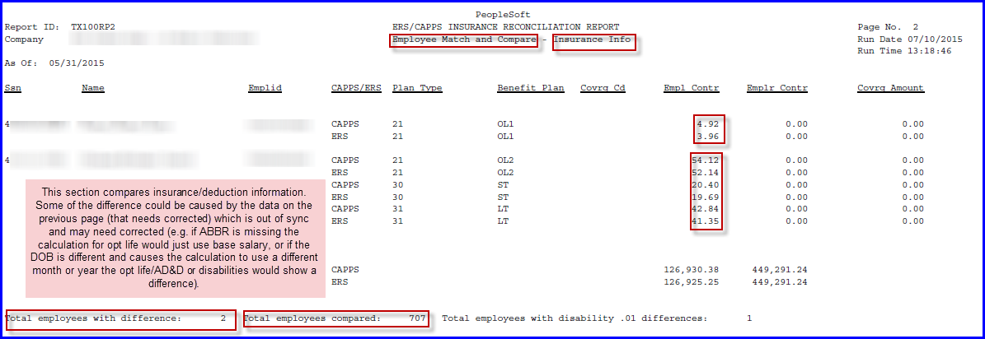
Comparison of enrollment/deductions between ERS & CAPPS (only difference will print)
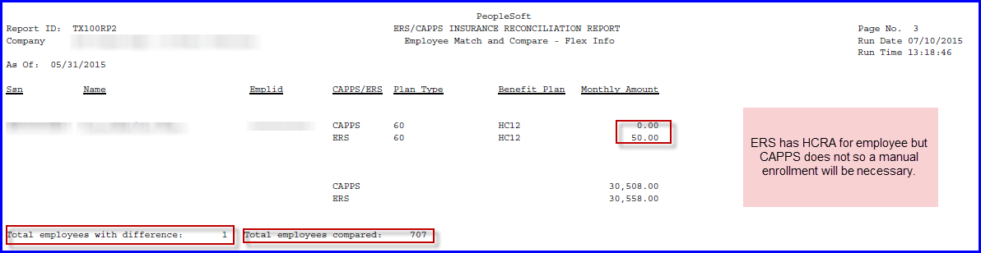
Flex differences between ERS & CAPPS
Note: Some of these differences may result in one-time adjustments to either refund or recover monies after analysis is completed.

