Voucher Entry- Add Freight Line on PO Voucher
Use this job aid if you did not enter Freight on the PO.
- Main Menu > Accounts Payable > Vouchers > Add/Update > Regular Entry.
'Add a New Value'
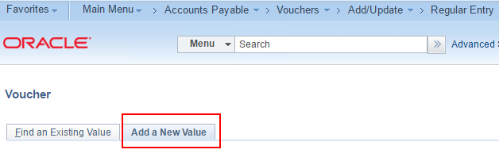
- Enter Supplier ID, Invoice Number and Invoice Date
and click Add.
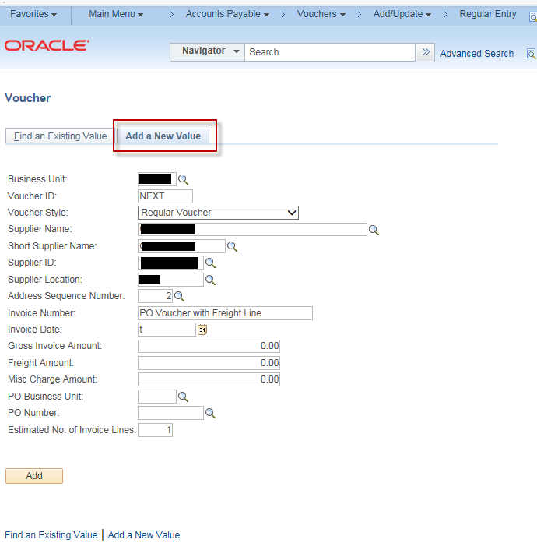
- On the Invoice Information page, click the triangle button to open
Copy From Source Document
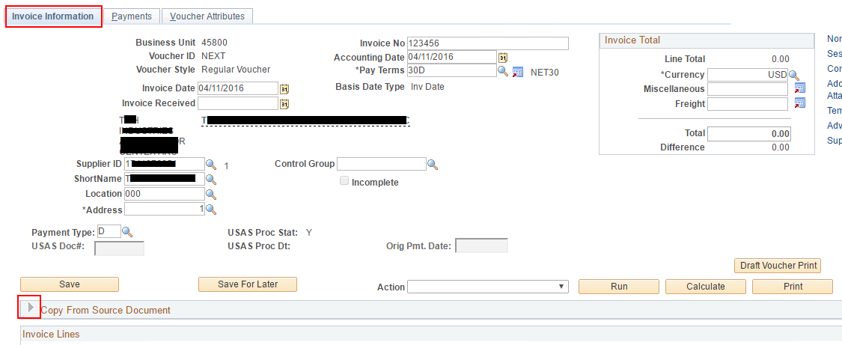
- In the 'Copy From' dropdown list, choose 'Purchase Order Only' and click Go.
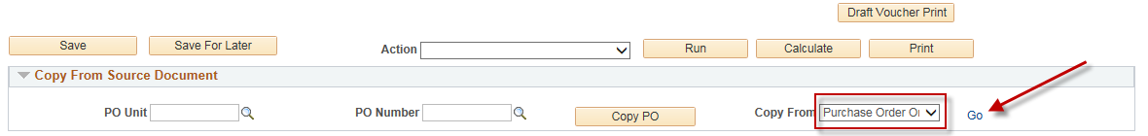
- In the Copy Worksheet page, enter PO Business Unit and PO Number From and click Search.
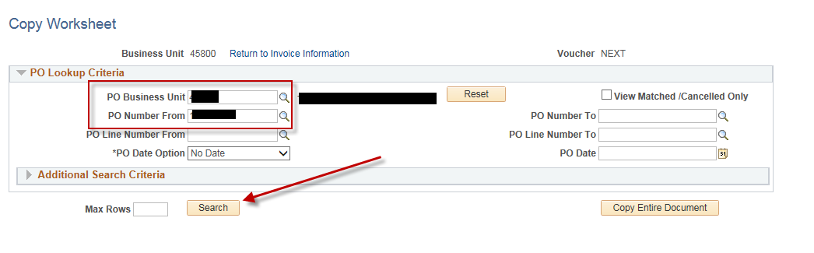
- Select the line or lines needed and click Copy Selected Lines
Navigate the lines as needed to select the lines needed for payment before clicking
Copy Selected Lines.
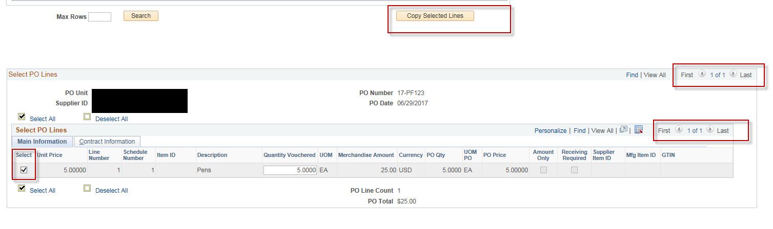
- Enter the Inv Receipt Dt, Service Date and Invoice Description.
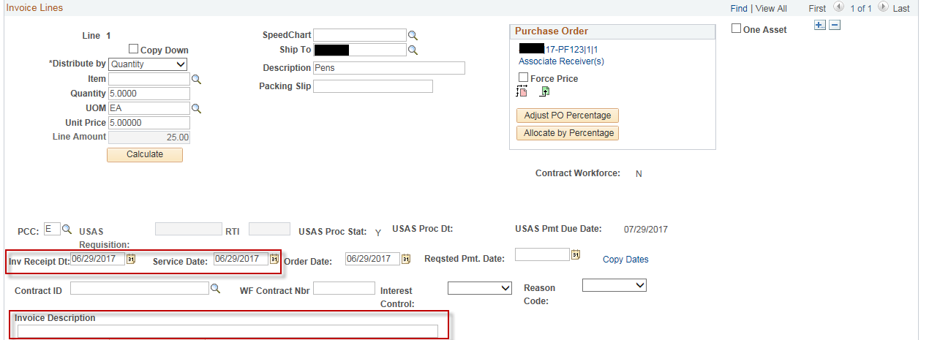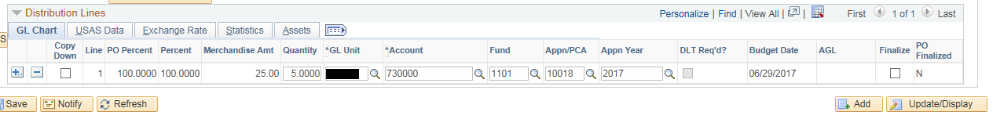
- Click the “+” button in order to add a new voucher line
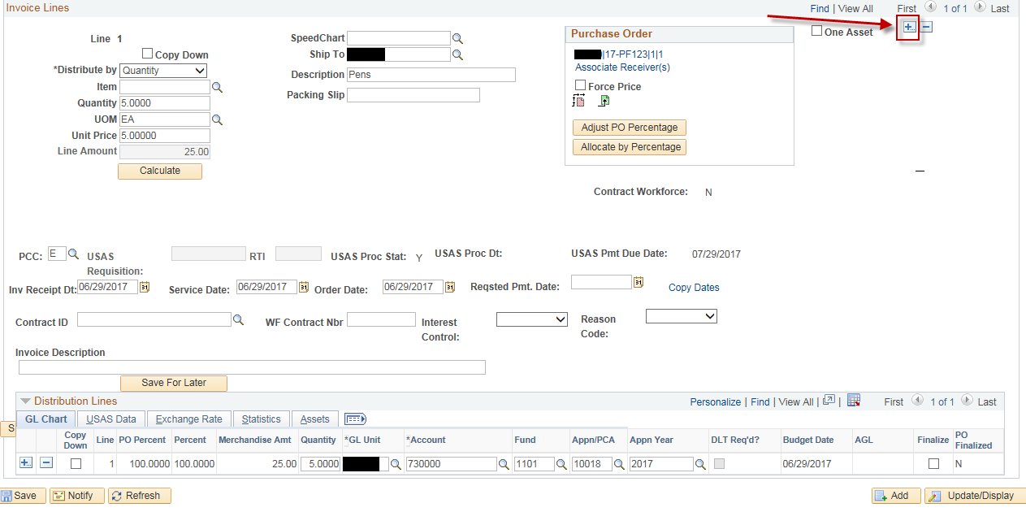
- Click “OK” to add 1 line.
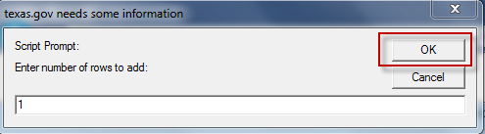
- Enter Description, Line Amount, Invoice Receipt Date, Service Date, Invoice Description, USAS Requisition Number (If the PCC <> 0, this field will be enabled and the value you enter here should be the same as your CAPPS PO #) and GL Chartfields (these vary by agency).
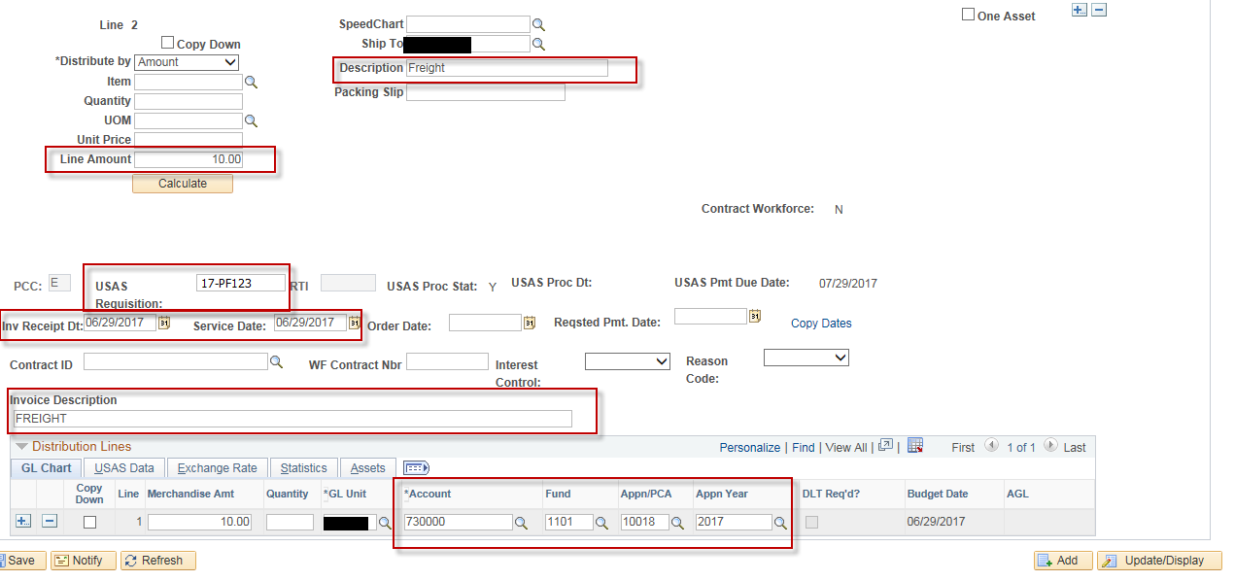
NOTE: Matching and Doc Tolerance will NOT apply to this voucher line since it was not copied from a PO.

- Update the voucher Total amount on the voucher header to include the Freight and click the “Calculate” button
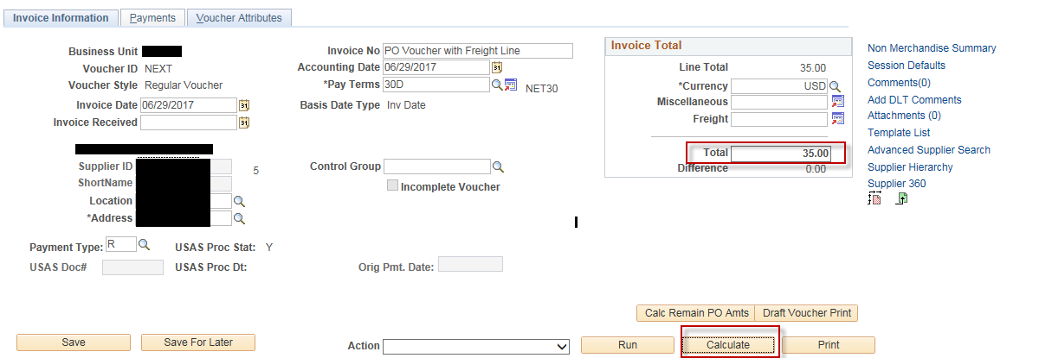
- Save the voucher.
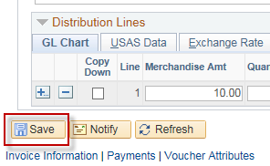
- Click “OK” if you get a message saying “Difference between voucher and total payment amounts is ……”
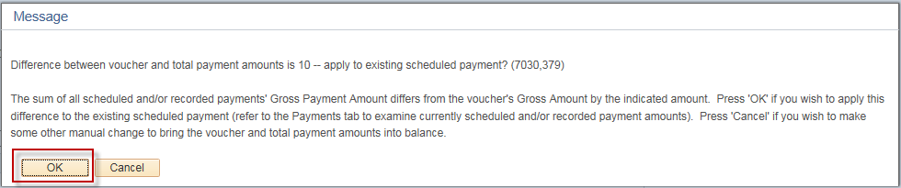
- Select Match, Doc Tol, Bdgt in the 'Action' dropdown list and click Run.
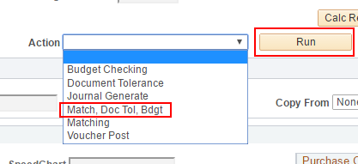
- Click the Refresh button to determine when the process has completed.

- When the processes have completed, go to the Summary page to verify the voucher's Match, Doc Tol and Budget status.
