CAPPS AM Reviewer User Training Guide

Search for an Asset: Use this page to search an asset based on specified criteria.
- Navigate to: Main Menu > Asset Management > Search for an Asset
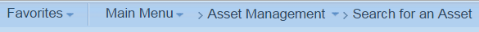

- Enter: Business Unit: 45800. To nail down your search, enter other search criteria such as Location. Check Cost Information, Acquisition Information or any other boxes so the information can be populated. Click Search
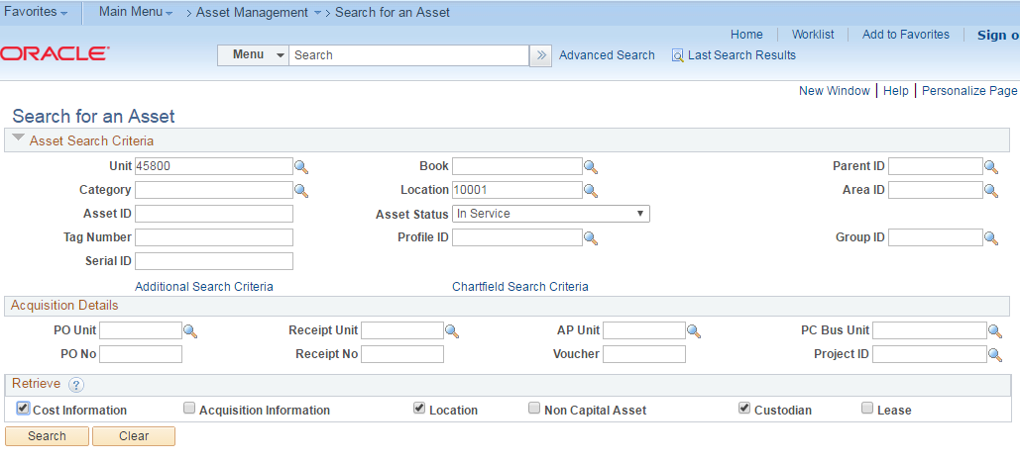
- Click Additional Search Criteria for additional search criteria
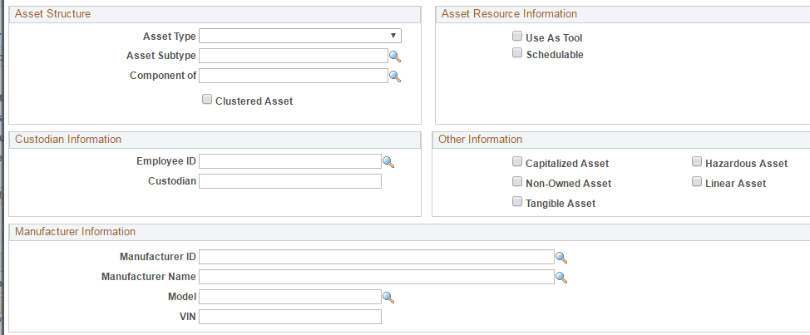
- Click Chartfield Search Criteria for additional search criteria
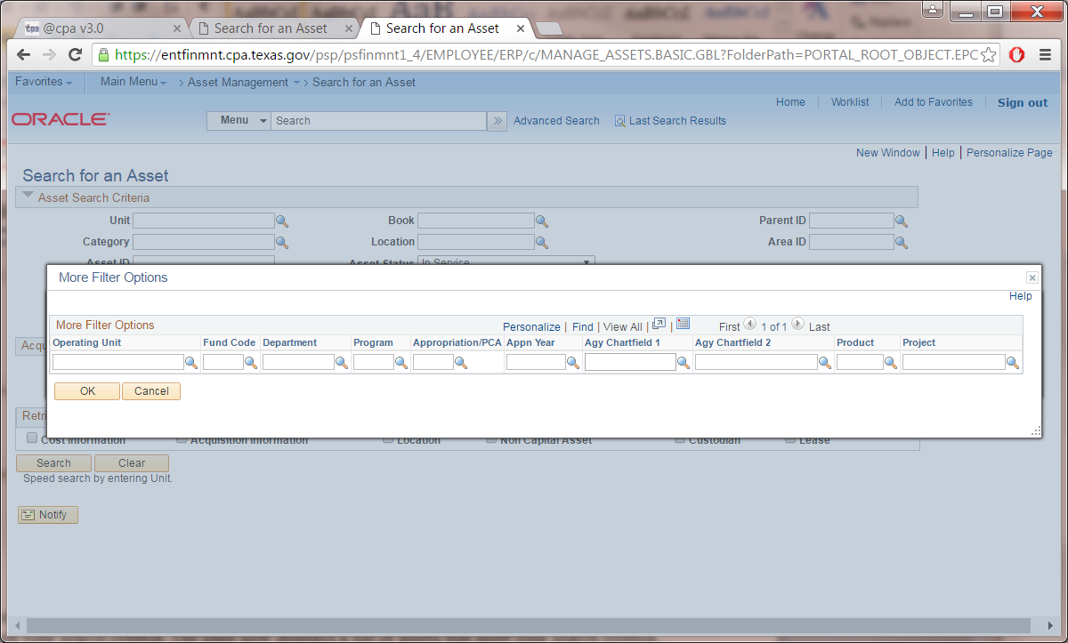

- Switch to other tabs such as Owner/Custodian to display Employee ID and Custodian.

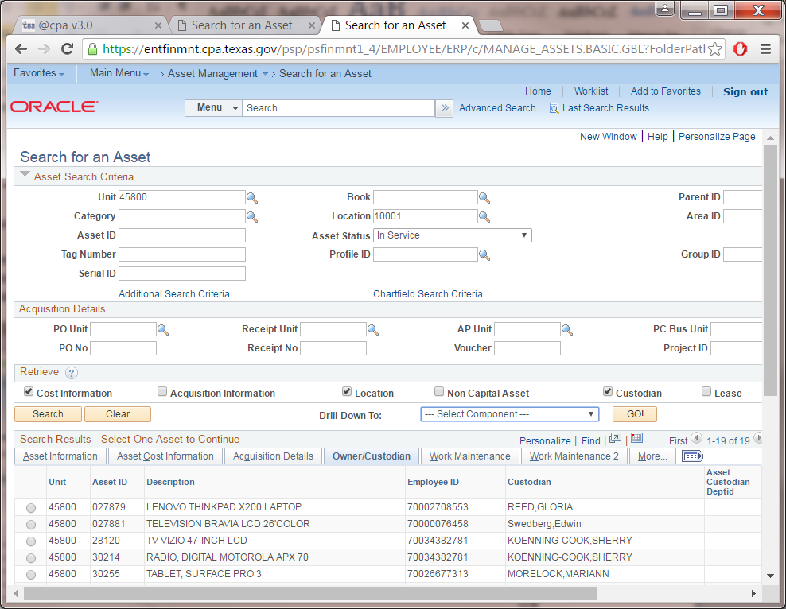

- The 'Drill-Down To' field enables you to review detailed information about a selected asset for different Asset Management components, such as Asset Accounting Entries.

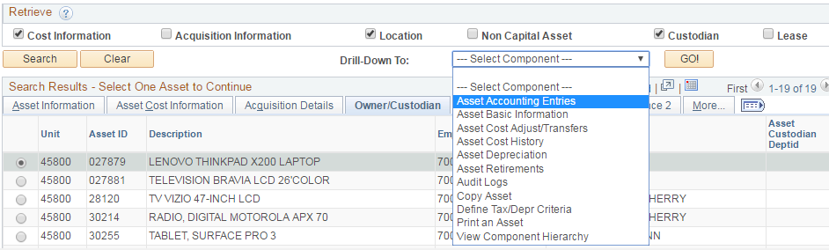
- By clicking on 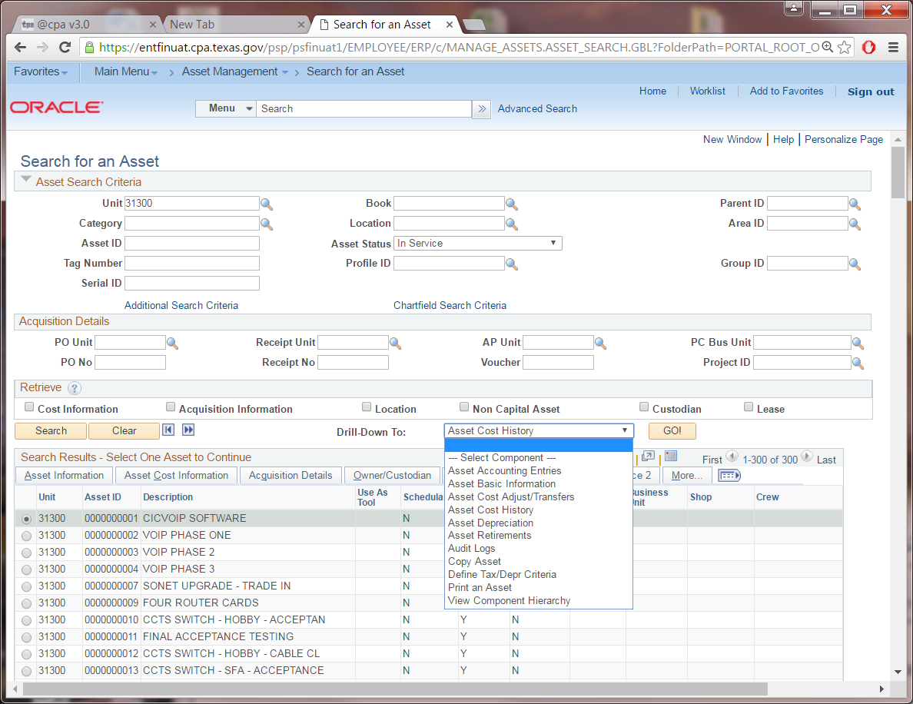, the search results can be downloaded to an Excel spreadsheet.

Asset Basic Information: Use this page to search for an asset financial and physical information such as an asset cost, class, PO/voucher details, location, custodian and serial number.

Navigate to: Main Menu > Asset Management > Asset Transactions > Owned Assets > Basic Add

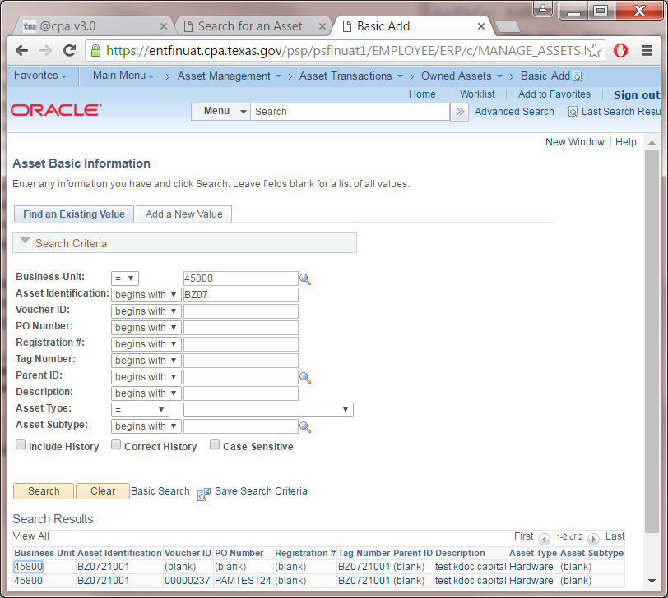

- Enter: Business Unit, asset ID or any other search criteria, then Search. You can enter a partial value to display a group of assets.

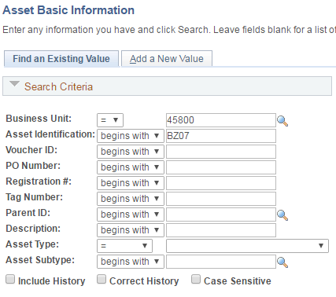

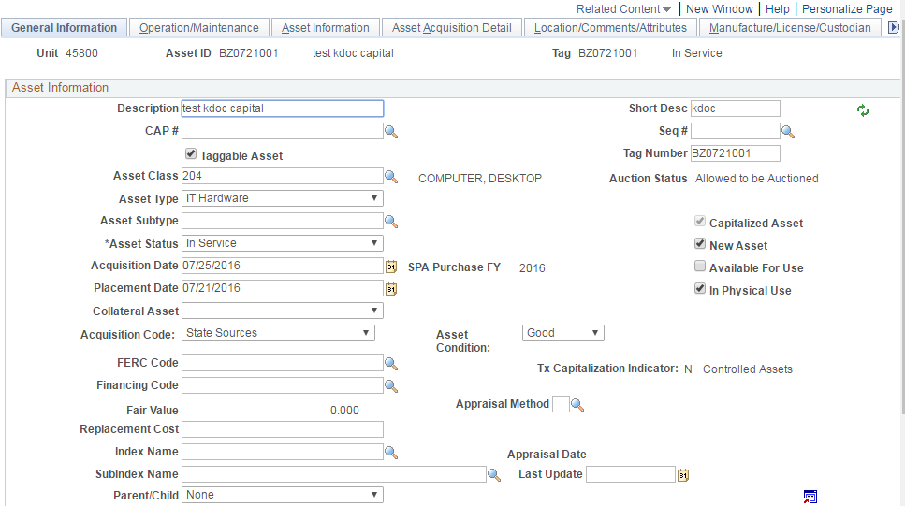

- Navigate to different tabs.
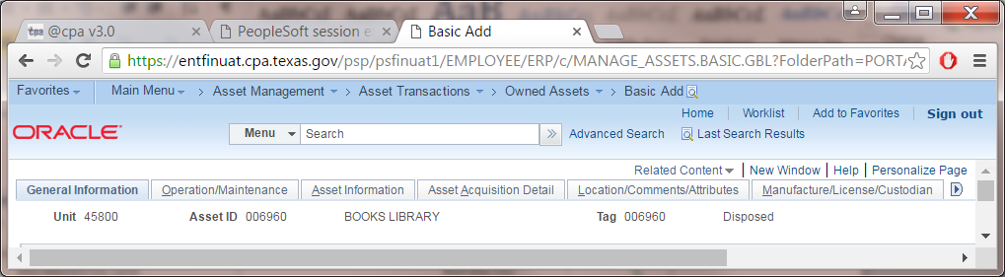
- Click on Asset Acquisition Detail tab, the System Source field shows if an asset is added online or added via PO/AP interface.
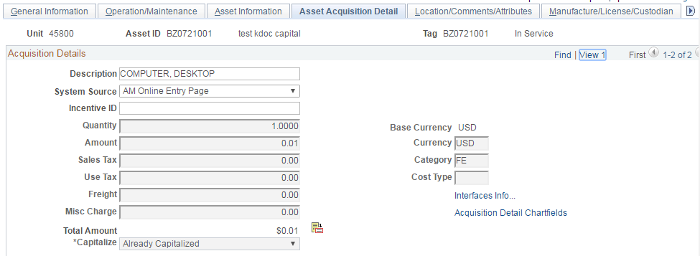

- Click on the Interface Info link, the Acquisition Details page should be displayed. It has voucher and PO information.

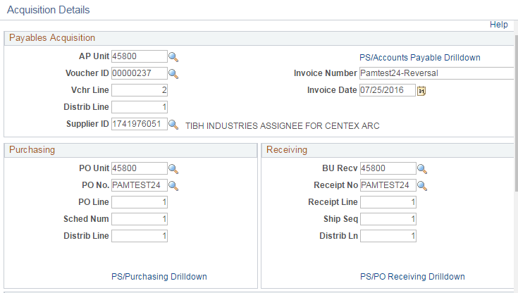

- Click on the Location/Comments/Attributes tab to see the asset location and other asset attributes.
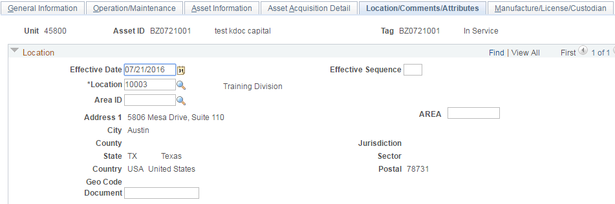

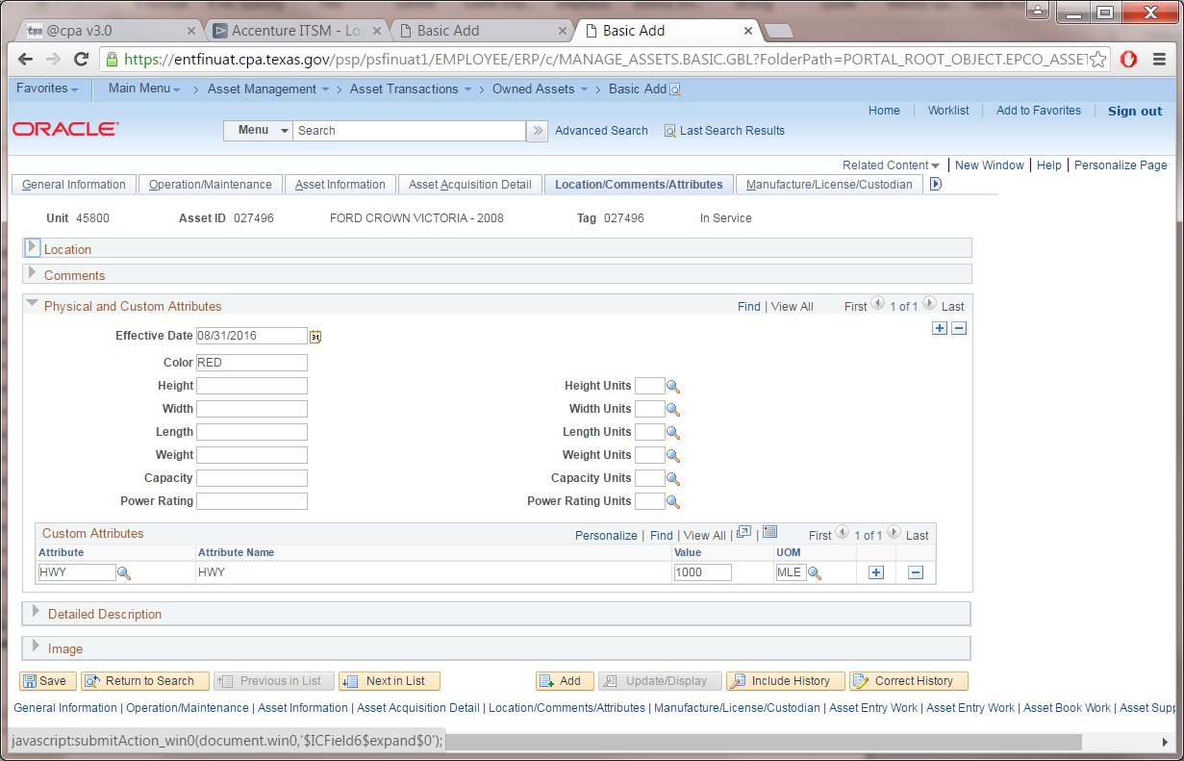

- Manufacture/License/ Custodian tab has asset custodian information. 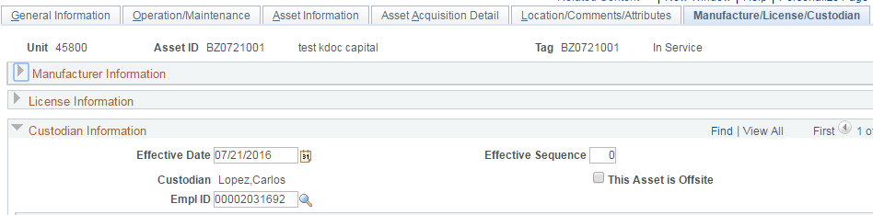

Print an Asset: Use this page to print a specific asset information.

- Navigate to: Main Menu > Asset Management > Print an Asset

- Enter: Business Unit and Asset ID, click Search button.

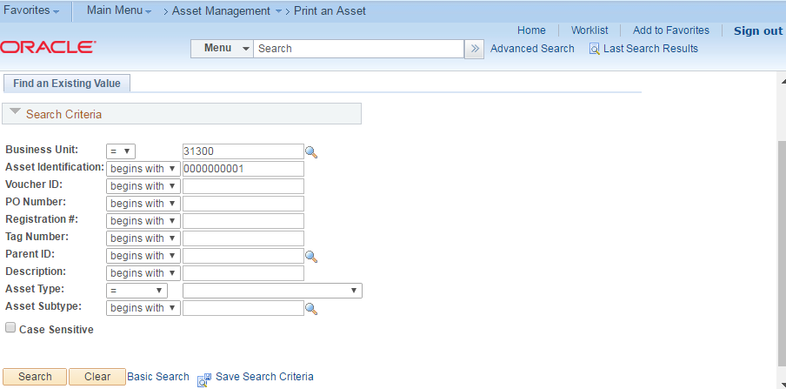

- The printable view of the asset page is displayed.

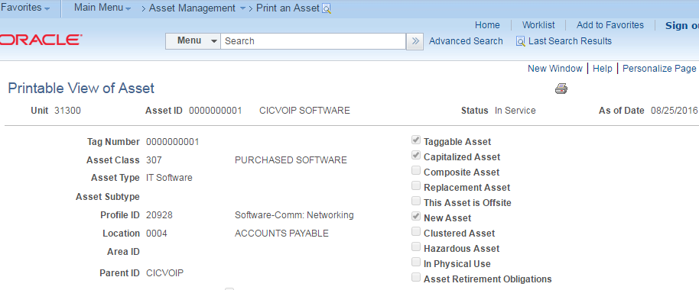

- Click on the print icon, an Asset_Print.pdf page is displayed.

