

CAPPS
Statewide Financials



CAPPS to SPA Interface
User Guide

July 2017

Table of Contents
Introduction 3
CAPPS and SPA interfaces: 3
CAPPS to SPA Integration 5
CAPPS to SPA Reconciliation 13
CAPPS Reconciliation Report 13
CAPPS to SPA Surplus Property Functions – Effective 9/1/2017 16
Appendix A – Data Mapping CAPPS to SPA Integration 23
Appendix B – SPA Reconciliation values 29
Appendix C – SPA Disposal Method Changes for FY18 31

Introduction
The State Property Accounting (SPA) system is the capital asset component of the Uniform Statewide Accounting System (USAS) maintained by the Comptroller's office as authorized by TEX. GOV'T CODE ANN. sec. 403.271(b). This centralized system of agency property records provides useful information to Legislative oversight agencies. It is also used in compiling the state’s Comprehensive Annual Financial Report (CAFR). The SPA system also provides assurance that state agency assets are accounted for and properly maintained.

With the rollout and implementation of CAPPS, fixed asset details for cost and asset details can be automatically integrated to the State Property Accounting (SPA) system.

CAPPS and SPA interfaces:
There are three processes to the CAPPS to SPA integration:

- CAPPS to SPA Integration - processes that integrate asset additions, retirements and cost adjustments from CAPPS to SPA. SPA interface errors and Pass/Fail status are also updated in CAPPS by the SPA transaction status update.

- CAPPS to SPA Reconciliation - process that validates and compares assets between CAPPS and SPA and reports on the results.

- CAPPS / SPA / TFC Surplus Property Integration - processes that retrieve data from SPA based on surplus property processing results of the Texas Facilities Commission (TFC). Users can monitor the status of surplus property in CAPPS and make retirements in CAPPS when appropriate for the hard disposals.

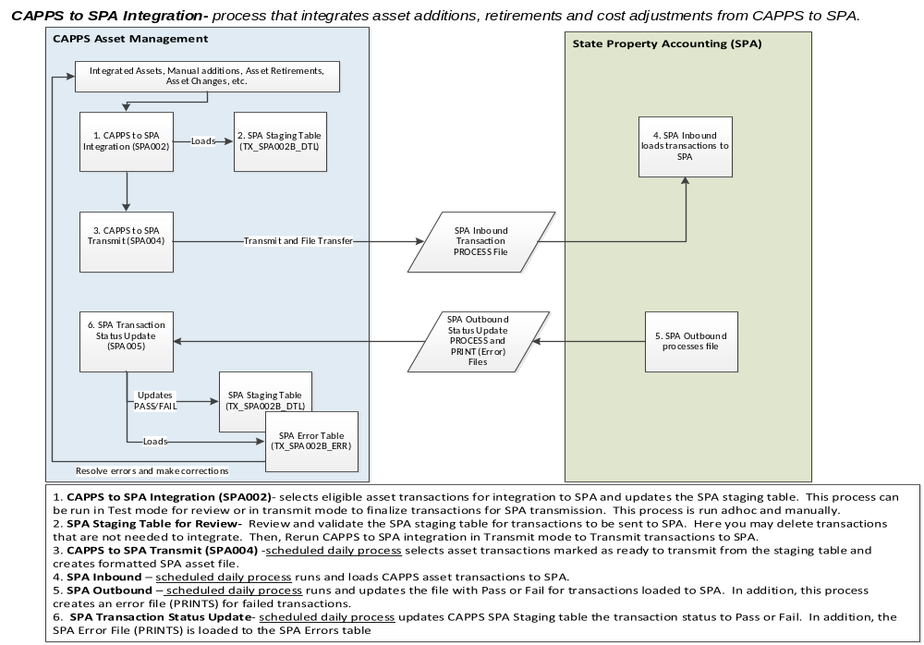

CAPPS to SPA Integration

Step 1: CAPPS to SPA Interface program (SPA002) - This process loads CAPPS asset additions, retirements and eligible changes to the SPA staging table.

- Test Mode- When SPA002- CAPPS to SPA interface is run in Test mode asset transaction updates are available for review prior to sending to SPA.
- Transmit Mode- When the interface is run in Transmit mode, transactions are flagged as ready to send to SPA and will be transmitted to SPA for loading at the next scheduled SPA file transmission process.

The CAPPS to SPA Interface program can be run manually when an agency is ready to review assets eligible to send to SPA. However, an agency may choose to schedule this process to run automatically. Many agencies prefer the process to be run automatically once per week or twice per month.

The run control for running the CAPPS to SPA interface is:

Navigation: Main MenuStatewide InterfaceSPA InterfacesCAPPS to SPA Interface

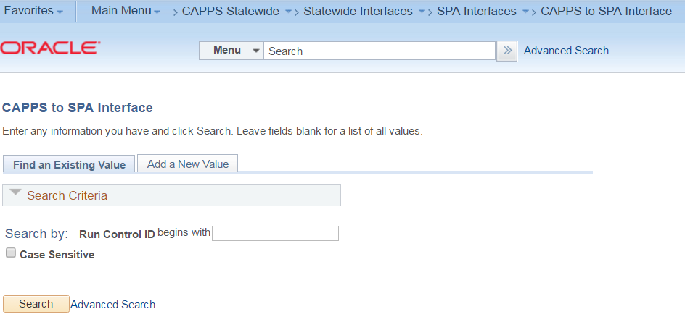

Select the Add a New Value tab and enter a unique Run Control ID

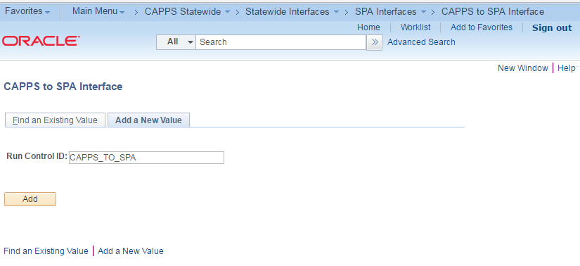

Click on the Add tab and Select Business Unit and Transmit File (Y/N)

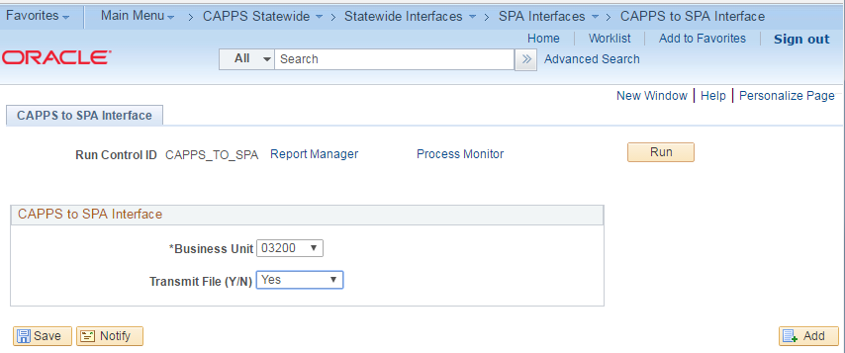
Select No, to run in review mode.
Select Yes, to run in the transmit mode to SPA

Save the page

The types of asset transactions included in the CAPPS to SPA integration include new asset additions from A/P integration, manual asset additions, asset adjustments, most of the asset disposals, correcting asset physical information, etc. Assets must be CAPATALIZED either via PO/AP integration or manual asset additions. Capitalization in this context simply means that the asset must have a record on the cost table with an amount greater than $0.

Click on the Run tab. The Process Scheduler Request page displays

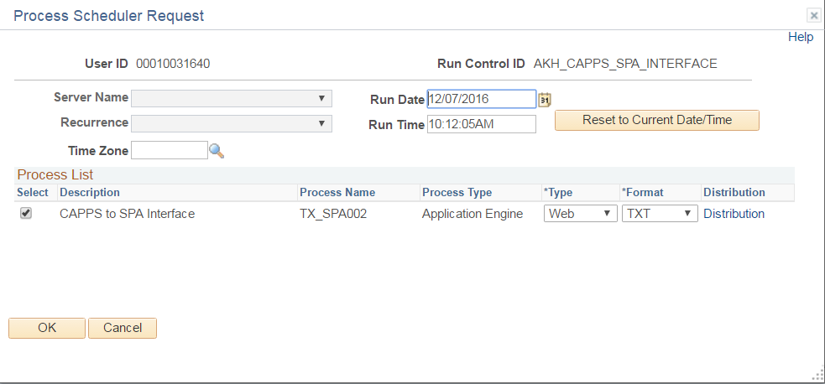

Click on the OK button

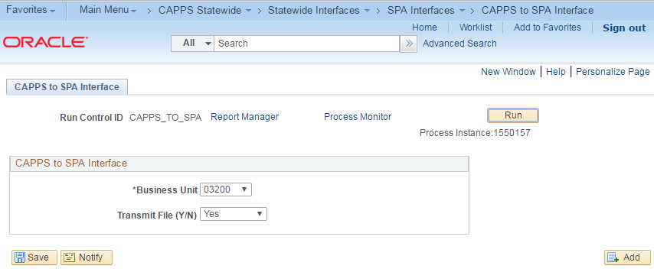

The job, TX_SPA002 has been submitted and Process Instance # assigned

Click on the Process Monitor to view status of the job

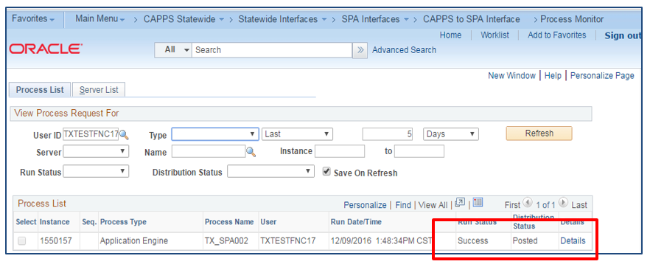

Run Status = Success. (Indicates the status of the process, such as Queued, Initiated, Cancelled and Success

Distribution Status: Posted. (Displays the distribution status for each individual job and process. Valid states are: N/A, None, Generated (OS390), Not Posted, Posting, and Posted.)

View Process details: To access the Process Detail page, click the Details link on the Process List page.

Step 2: Review SPA Staging Table – After the CAPPS to SPA integration is successfully run, the SPA Staging table TX_SPA002B_DTL is reviewed that displays the eligible asset transactions to submit to SPA. Here you can evaluate and or delete transactions that are available for submission to SPA.

Navigation: Main MenuCAPPS StatewideStatewide InterfacesSPA Staging Table
Select Agency from the drop down box

Click on the Search tab to review Staging SPA transactions.

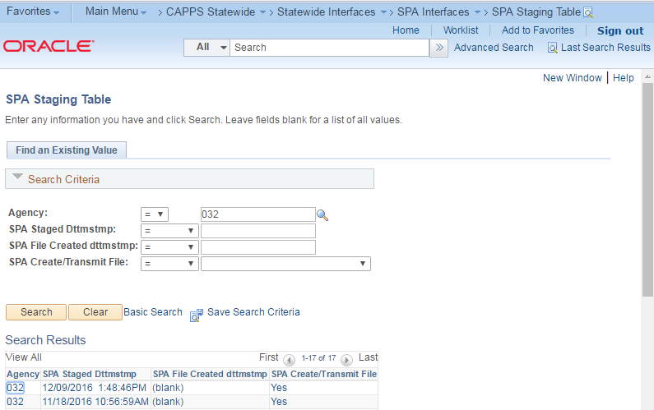

Search for the SPA staged date time, for the latest run of the process. It is usually the first report in the Search Report box

Click on the SPA Staged Dttmstmp to open it

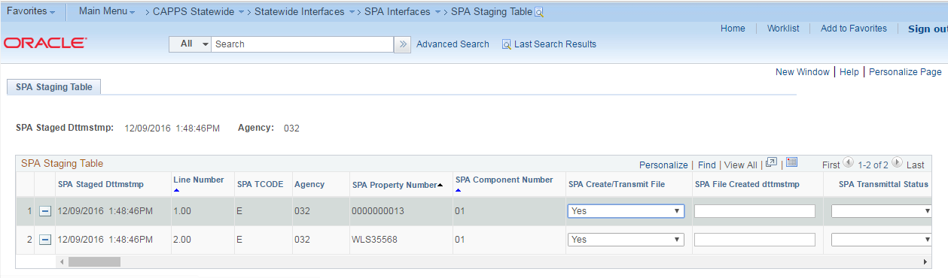

SPA Staged Dttmstmp - this is the date and time that the CAPPS to SPA integration is run.

SPA TCode - The types of transaction selected for candidates eligible to be transmitted to SPA are based upon T-codes (transactions):

(blank) - physical asset changes, i.e. asset class code, description.

I - Initial asset additions
D - Asset decrease in value.
A - Asset increase in value
E - Asset Retirement

SPA File Created Dattmstmp- initially blank, this is the file create date and time stamp for when the scheduled SPA process that creates the file inbound for SPA. This update occurs at the time of the scheduled SPA transmittal (SPA004) process.
SPA Transmittal Status – initially blank the transmittal status Pass/Fail indicates the load status of the transaction to SPA. This status is updated after the scheduled SPA transaction status process (SPA005).

Important: At this time, you will want to make sure there are no asset transactions that need to be assigned Parent/Child relationships prior to sending to SPA. Once an asset is sent to SPA and a SPA property number assigned, it is difficult to establish SPA component asset relationships.

Optional: if there are transactions that you do not want to transmit to SPA, i.e. you have already entered in SPA, you may delete these from the SPA staging table by selecting the minus sign. See Below:

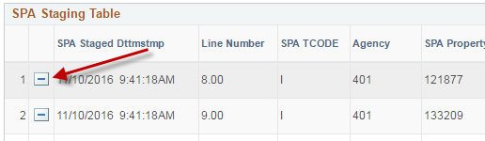

Please refer to Appendix A - CAPPS to SPA mapping table for values mapped in the CAPPS to SPA interface.

Step 3: CAPPS to SPA Transmit (SPA004)

- Re-run Step 1 in Transmit Mode: Navigation: Main MenuStatewide InterfaceSPA InterfacesCAPPS to SPA Interface
- The daily scheduled CAPPS to SPA Transmit process creates the file for eligible transactions and makes available for the SPA Asset Inbound load process.

Step 4: SPA Inbound Process - the daily scheduled SPA inbound process performs a SPA upload nightly for asset transactions from the PROCESS file.

Step 5: SPA Outbound Process - the daily scheduled SPA Outbound Process updates the PROCESS file created in Step 4 with asset transactions status of Pass or Fail. In addition, there is an error file (PRINTS) file that is written for failed assets along with the SPA Asset Error message.

Step 6: SPA Transaction Status Update (SPA005) - this is a nightly scheduled process that updates the transaction status for SPA assets on the SPA Staging table with the SPA status of Pass or Fail. This process also will insert to the SPA Error Table the total assets processed and total failed along with the detailed error message for assets that failed in the SPA load process.

After the nightly process is run, the SPA PRINT Error table is reviewed for processed transactions and the number of transactions that failed.

Navigation: Main MenuStatewide InterfaceSPA InterfacesSPA PRINT Error

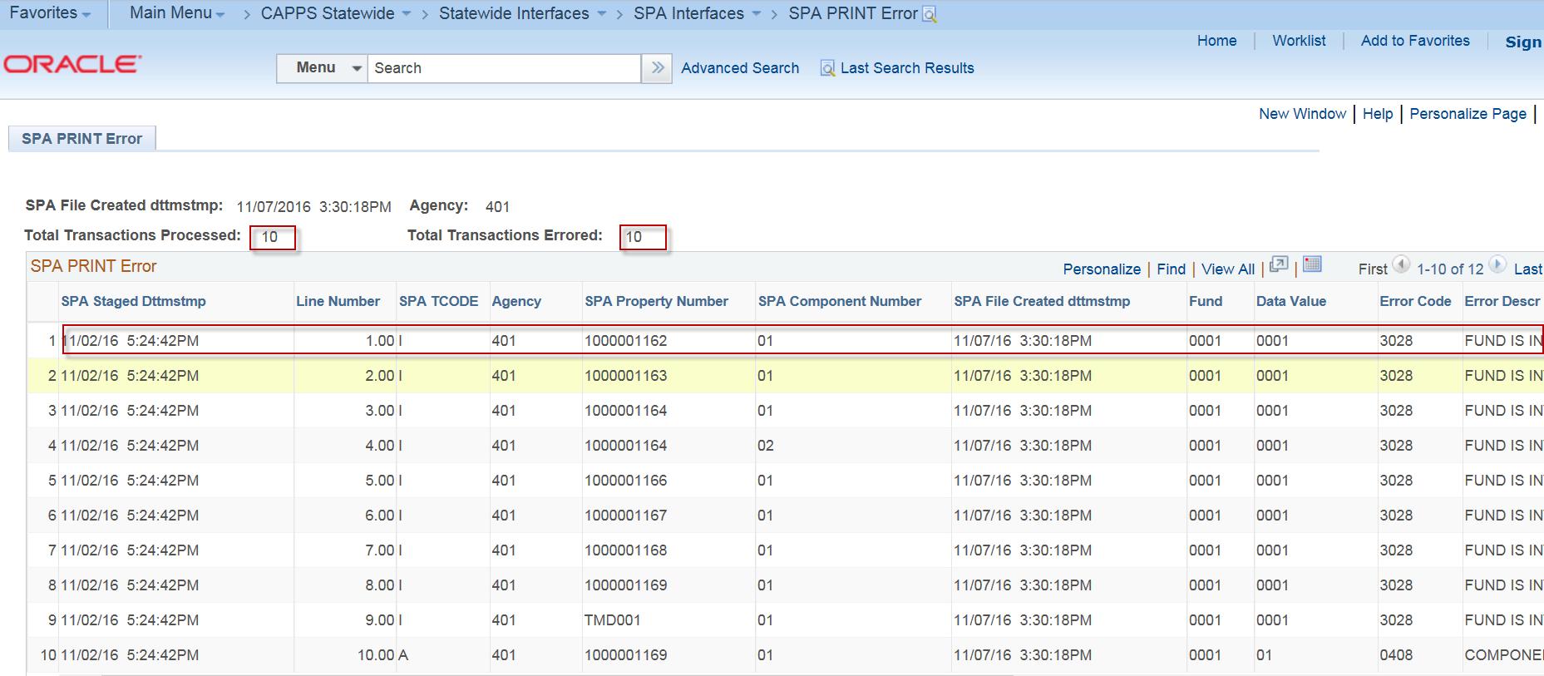

Total Transactions Processed is the number of transactions that were included in the SPA load process.
Total Transactions Errored is the number of transactions that failed in the SPA load process.

The detailed SPA Print error table identifies the SPA property number, component number, error data value and SPA error description as to the reason a transaction failed in the SPA interface load. If unable to resolve the error, you may submit an SR in ASP solution center to contact a CAPPS analyst to assist you in correcting the data value error.

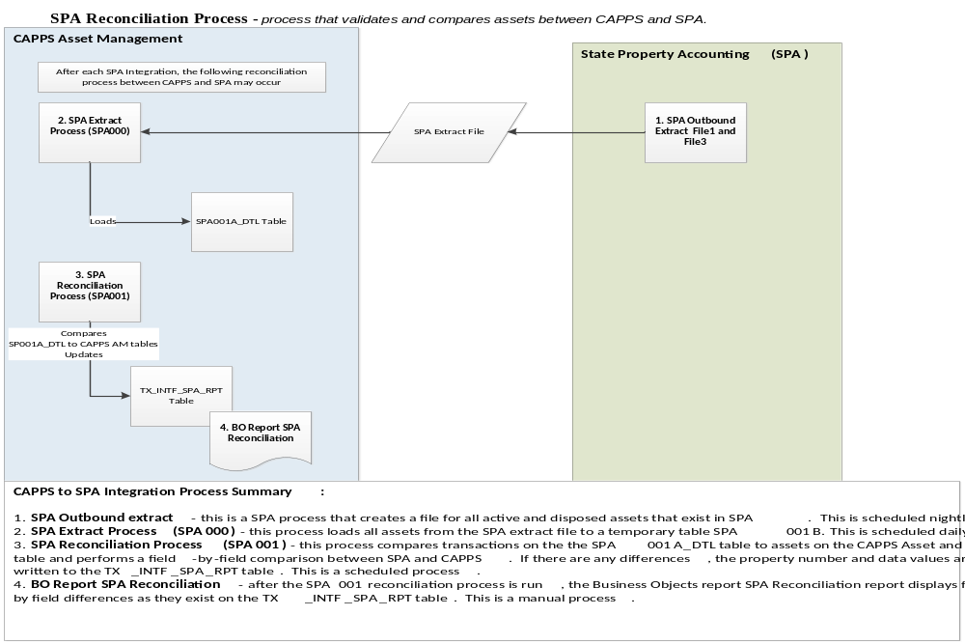

CAPPS to SPA Reconciliation
Step 1: SPA Extract File- SPA generates two extract files nightly from SPA (File1 and File3). These files contain all SPA asset details. This is an automatic process run every night.

Step 2: SPA Extract Process (SPA000) – the SPA Extract process loads from the SPA file all active and disposed assets (as of 1 year prior) for reconciliation. Agencies will first need to request a SPA extract from SPA to provide the daily extract. The SPA000 loads the extract file from SPA for all assets to the TX_SPA001B_DTL table. This process is automatically scheduled to run daily at 6:00 a.m.

CAPPS Reconciliation Report
The SPA001 process compares SPA transactions from TX_SPA001B_DTL table to CAPPS asset tables and writes reconciliation differences to the TX_SPA001A_DTL details table. In the comparison, this table identifies field-by-field differences for each asset.

Step 3: CAPPS Reconciliation Report (SPA001) - To run the CAPPS Reconciliation report, use the below navigation:

Navigation: Main Menu>CAPPS Statewide>SPA Interfaces>SPA Reconciliation Report

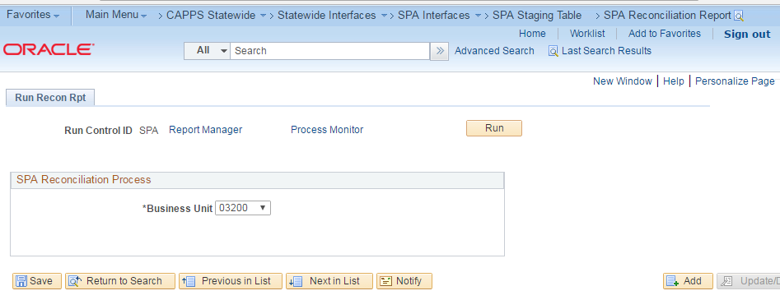

Please refer to Appendix B: CAPPS Reconciliation values for CAPPS tables and fields compared in the CAPPS to SPA reconciliation.

The SPA to CAPPS reconciliation report CAPPS to SPA differences for users to research and verify. Depending on the agency asset volume, this process can be run monthly, quarterly or yearly.

Step 4: CAPPS Reconciliation Report

The business objects report CAPPS Reconciliation report displays these results:

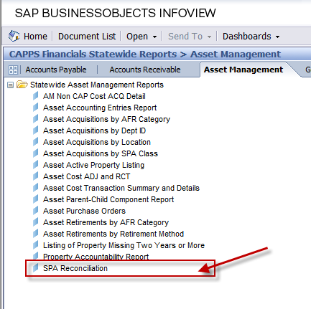

When you enter the agency business unit and select the reconciliation process, the following report displays:
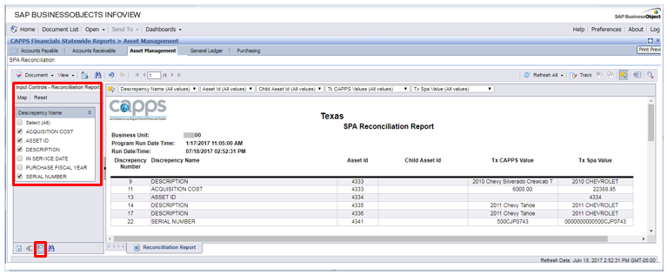

Note that the report is designed with Input Controls, which can be accessed on the left panel. You can select and de-select the discrepancy values, focusing on the most important to you and filtering out the rest.

The following are some common CAPPS to SPA errors and the proposed solutions to reconcile CAPPS to SPA transactions:

SPA Reconciliation Error | Possible Causes | To Correct
Asset ID in SPA not in CAPPS | Asset is entered in SPA was not entered in CAPPS | Manually add asset to CAPPS
Asset ID not in SPA but in CAPPS | - Asset add transaction failed in the CAPPS to SPA integration.  - CAPPS to SPA process not run since additions. | - Manually add asset to SPA.  - Run the SPA002
CAPPS Asset Cost does not equal SPA Asset Cost | - Asset transaction failed in SPA integration.  - CAPPS to SPA process not run since cost transaction. | - Manually adjust SPA cost to equal CAPPS cost.  - Run the SPA002

CAPPS to SPA Surplus Property Functions – Effective 9/1/2017

HB3438 moved responsibility for maintaining the ‘Advertise Surplus Property’ website from the Comptroller's office to the Texas Facilities Commission (TFC). ACR 60136, which was completed in August of 2015, providing a nightly automated file listing assets in disposal method 05 for TFC. TFC set up a website for advertisement of these surplus properties.

The Texas Facilities Commission requested changes to the SPA system to aid in improving the surplus process and in increasing TFC’s control over surplus assets. SPA ACR60149 was initiated to handle these additional changes to include the modification of SPA to allow for an incoming disposition file from TFC.

See FMX for more information: https://fmx.cpa.texas.gov/fmx/changes/spa/60149.php

CAPPS has also made changes under modification STW1389 (SR8000) that will accommodate changes made by SPA while minimizing negative impacts to the CAPPS users. All of these changes will be effective September 1, 2017.

New in CAPPS:
- Process to load surplus disposition information from TFC/SPA into CAPPS
- Page and record to view the surplus information from TFC/SPA
- Controls to ensure the correct Disposal Method is used in CAPPS based on the surplus status
- Controls to ensure serial number is entered when adding an asset in CAPPS based on the class code requirements
- Asset class attribute fields indicating whether:
  - Serial number is required
  - Required when using DM14
- Removal of obsolete disposal methods, adding new ones, and updating descriptions

The basic steps to retire an asset in CAPPS have not changed, just the available Disposal Methods and controls to ensure the correct method is selected.
The high-level data-interfacing path between SPA-TFC-CAPPS is shown in the graphic below:
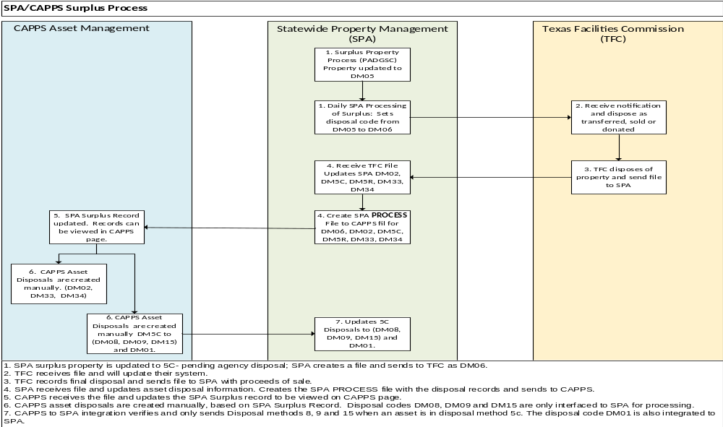

The first step in the disposition of surplus property is made in SPA. Access the new Surplus Property Process screen (PADGSC) and enter all required information.
(For more information on ACR 60149, see the FMX site here: https://fmx.cpa.texas.gov/fmx/changes/spa/60149.php)
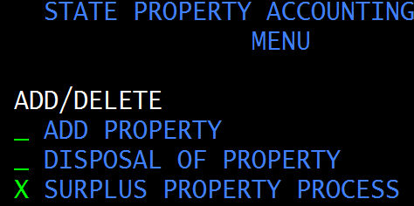
After entering all required information and saving, the property is updated to disposal method (DM) “05 Pending”. Note that serial number will be required for certain class codes. SPA will not allow a save to surplus if the asset does not have a serial number and has a class code on the required list.
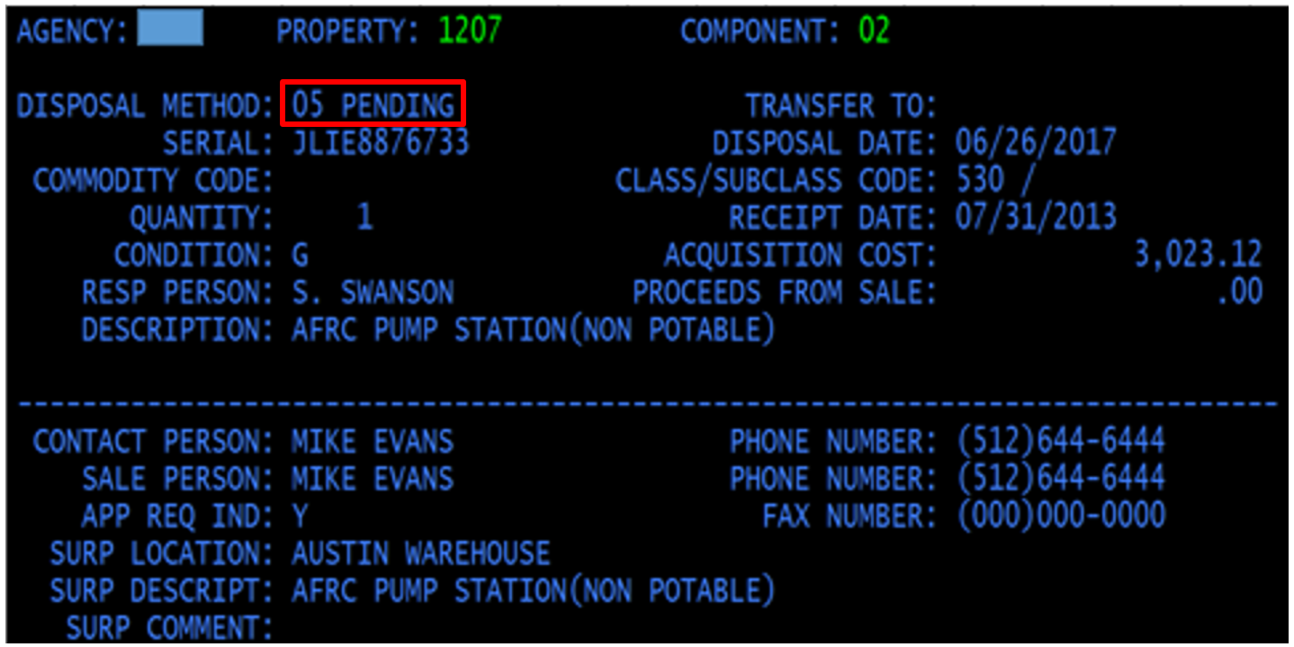

Access the SPA inquiry screen to check the status:
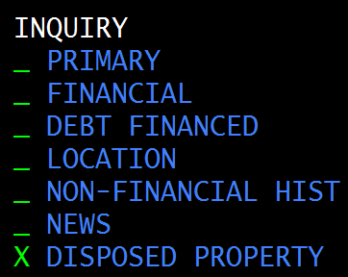
Daily processing by SPA updates the DM from 05 to 06 and sends the data to TFC.
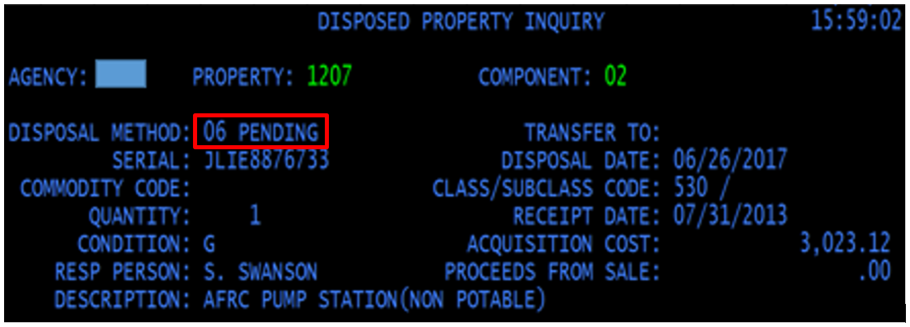
After TFC makes the final disposition of the property, the return file is processed by SPA and the property record is updated. In this case, the property is updated to 5C, indicating that the property was either sold or donated to a political subdivision or TFC approved assistance organization, or it was placed in the TDCJ computer recovery program.
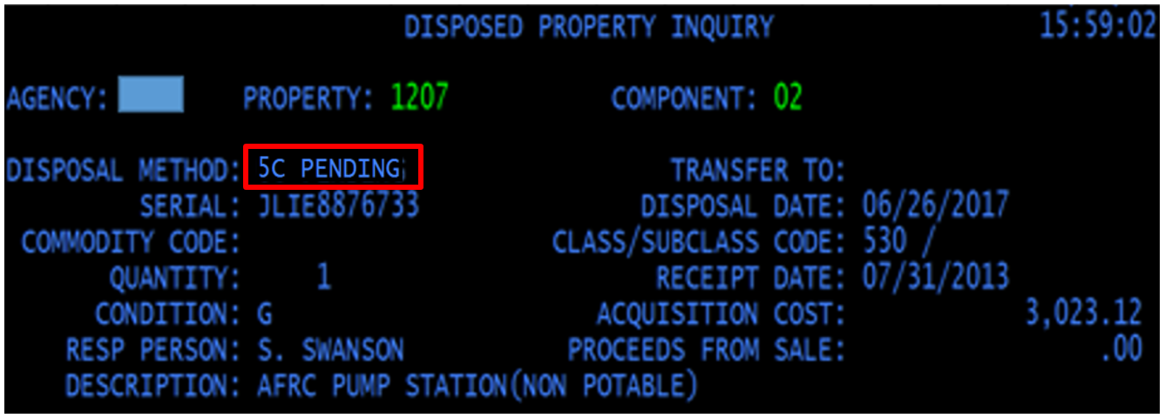

When SPA processes the incoming TFC file and updates the corresponding property in SPA, it also creates a PROCESS file representing that day’s transactions for all CAPPS agencies. CAPPS runs a daily process that retrieves the PROCESS file and loads the data to the new CAPPS surplus property record.
The surplus data can be viewed in CAPPS here:
The search results display the information needed to determine the next steps in CAPPS. In the example below, we want to see all the property rows with a surplus date in June.
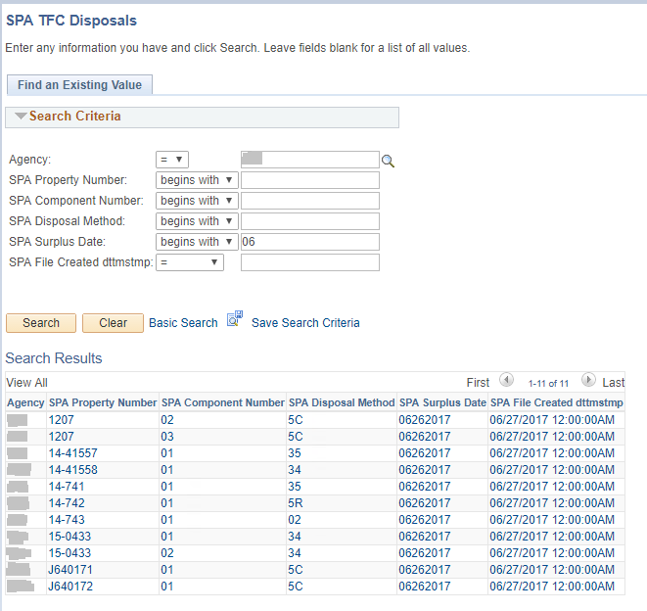

The values returned from TFC will be one of the five noted below. Retirements in CAPPS should be made with the associated DM as shown below.
TFC/SPA | CAPPS | CAPPS DM
02 | 01 | Completed Transfer
5C | 08 | Surplus Property Donated of Sold to a Political Subdivision
5C | 09 | Surplus Property Donated or Sold to a TFC Approved Assistance Organization
5C | 15 | TDCJ Computer Recovery Program
33 | 33* | TFC Surplus Process Sale
34 | 34* | TFC Donation
5R | n/a | Issue must be resolved with TFC prior to disposal
*DM33 and DM34 will not generate rows on the CAPPS to SPA staging table. SPA has already been updated automatically from the TFC data, so there is no need to send an update.
The basic CAPPS retirement procedures will not change: In this case, we retire with DM08 and add information in the “Retire To” field. Users will only be able to save retirements made with DM08, DM09, or DM15 when the property is in a 5C status.
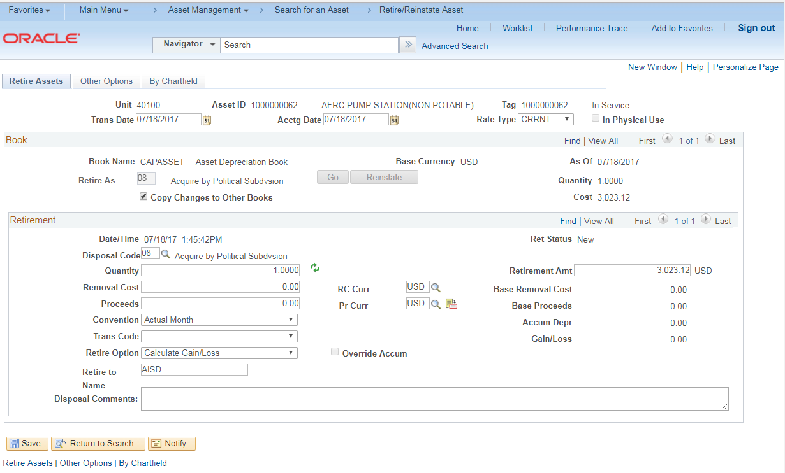

Note that CAPPS Asset 10000000062 in this example represents SPA Property 1207 / Component 02
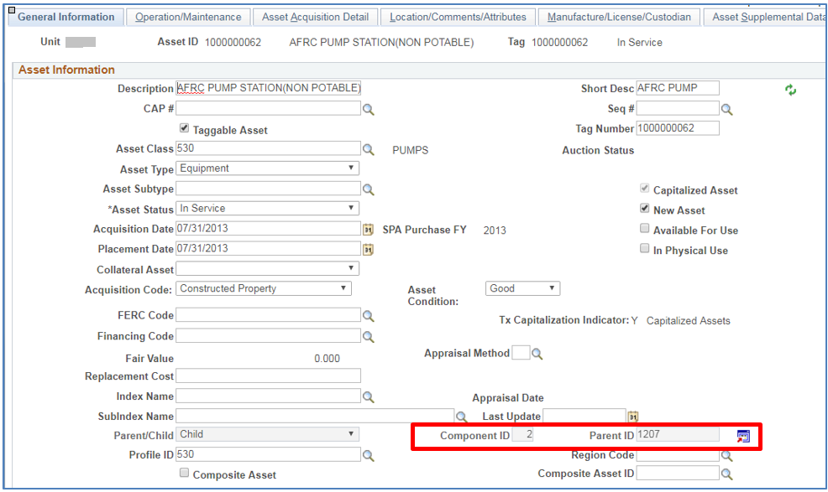
Once the asset is retired in CAPPS, and the CAPPS to SPA interface has been run, SPA is updated with DM08 as its final disposition.
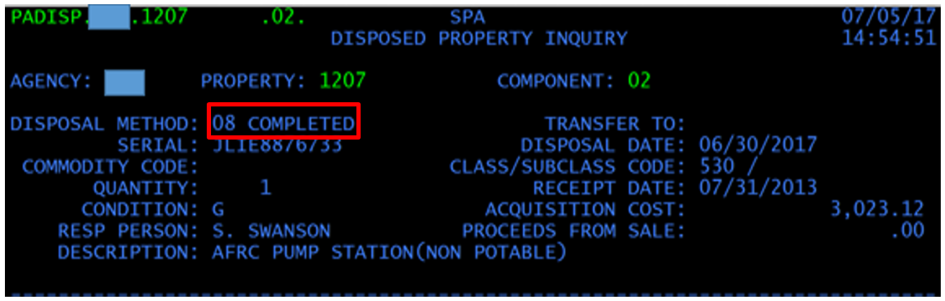

Appendix A – Data Mapping CAPPS to SPA Integration

All fields are located on Record: TX_SPA002B_DTL
FIELDNAME | FIELD TYPE | SOURCE
TX_SPA_DTTM_STAGED | DateTime | Current Date
TX_LINE_NBR | Number | TX_LINE_NBR +1
TX_SPA_TCODE | Character | A, I, D, E, R, " "
TX_AGENCY | Character | Substring(TX_AUDIT_ASSET.BUSINESS_UNIT, 1, 3)
TX_SPA_PROP_NUM | Character | TX_ASSET_COMP.ASSET_ID /  TX_ASSET_COMP.PARENT_ID /  TX_ASSET_AUDIT.PARENT_ID /  TX_ASSET_AUDIT.ASSET_ID/  ASSET.PARENT_ID/  TX_AUDT_ACQ_DET.ASSET_ID/  TX_AUDIT_DBT_FN.ASSET_ID/  TX_AUDIT_A_LOC.ASSET_ID/  TX_AUDIT_BOOK.ASSET_ID
TX_SPA_COMPNT_NUM | Character | TX_ASSET_COMP.TX_ASSET_COMP_ID /  "01"
TX_SPA_QUANTITY | Character | "00001"/  ASSET_ACQ_DET.TX_SPA_QUANTITY/  "*"
TX_SPA_EFFDT_CHAR8 | Character | For SPA Tcode = "I"  ASSET.ACQUISITION_DT (Current FY)  9/1/<current calendar year> (Prior FY & SPACLOSE = C)  ASSET.ACQUISITION_DT (Prior FY & SPACLOSE = O)  For SPA Tcode "A" & "D"  COST.ACCOUNTING_DT  For SPA Tcode " "  TX_AUDIT_ASSET.AUDIT_STAMP/  TX_AUDIT_BOOK.AUDIT_STAMP/  TX_AUDT_ACQ_DET.AUDIT_STAMP/  TX_AUDIT_DBT_FN.AUDIT_STAMP/  TX_AUDIT_A_LOC.AUDIT_STAMP  For SPA Tcode "R"  TX_AUDIT_BOOK.LAST_TRANS_DT
TX_SPA_INSVCDT_C8 | Character | For SPA Tcode = " " & "I"  ASSET.ACQUISITION_DT
TX_SPA_RCTDT_CHAR8 | Character | For SPA Tcode = " " & "I"  ASSET.ACQUISITION_DT
TX_SPA_VCHRDT_C8 | Character | VOUCHER.ACCOUNTING_DT
TX_SPA_VCHR_NUM | Character | TX_AUDT_ACQ_DET.VOUCHER_ID/  ASSET_ACQ_DET.TX_SPA_VCHR_NUM/  "*"
TX_SPA_PO_NUM | Character | TX_AUDT_ACQ_DET.PO_ID/  ASSET_ACQ_DET.PO_ID/  "*"
TX_SPA_REQ_NUM | Character | N/A
TX_SPA_DESC_TXT | Character | TX_AUDIT_ASSET.DESCR /  ASSET.DESCR /  "*"
TX_CLASS_CODE | Character | TX_AUDIT_ASSET.ASSET_CLASS /  ASSET.ASSET_CLASS
TX_SPA_SUBCLASS_CD | Character | N/A
TX_SPA_PROPCOMM_CD | Character | N/A
TX_SPA_MODEL_YR | Character | Year(TX_AUDIT_ASSET.PRODUCTION_DT) /  Year(ASSET.PRODUCTION_DT)
COMP_SERIAL_ID | Character | TX_AUDIT_ASSET.SERIAL_ID /  ASSET.SERIL_ID
TX_SPA_MANUFACTR | Character | TX_AUDIT_ASSET.MANUFACTURER/  ASSET.MANUFACTURER
TX_CAP_FLAG | Character | N/A
TX_SPA_USEFUL_LIFE | Character | TX_AUDIT_BOOK.LIFE/  BOOK.LIFE
TX_SPA_CMP_COM_TXT | Character | "See CAPPS system for comments"
TX_SPA_COND_CD | Character | TX_AUDIT_ASSET.TX_ASSET_COND_CODE /  ASSET.TX_ASSET_COND_CODE
TX_SPA_REASSIGN_CD | Character | "N"
TX_SPA_COUNTY | Character | LOCATION_TBL.COUNTY
TX_TRANS_FROM_AGY | Character | ASSET.TX_TRANS_FROM_AGY /  TX_AUDIT_ASSET.TX_TRANS_FROM_AGY /  " "
TX_SPA_PREV_PROP_N | Character | TX_AUDIT_ASSET.TX_PREV_PROP_NUM /  ASSET.TX_PREV_PROP_NUM
TX_SPA_CMP_SW_VER | Character | TX_AUDIT_ASSET.PROD_VERSION/  ASSET.PROD_VERSION
TX_SPA_FUND_NUM | Character | TX_AUDIT_COST.FUND_CODE /  PSTREENODE.PARENT_NODE_NAME
TX_SPA_ACQ_MTHD_CD | Character | TX_AUDIT_ASSET.TX_AGENCY_ACQ_CD /  ASSET.TX_AGENCY_AQC_CD
TX_SPA_APPROP_NUM | Character | " "
TX_SPA_PROJECT_NUM | Character | " "
TX_SPA_GRANT_NUM | Character | " "
TX_SPA_COMP_OBJ | Character | ASSET_CLASS_TBL.TX_CON_COBJ/  ASSET_CLASS_TBL.TX_CAP_COBJ
TX_SPA_AGY_OBJ_CD | Character | N/A
TX_SPA_PURCH_FYYR | Character | For SPA Tcode = " " & "I"  Fiscal Year of ASSET.ACQUISITION_DT  For SPA Tcode "A" & "D"  Fiscal Year of COST.ACCOUNTING_DT  For SPA Tcode " "  Fiscal Year of TX_AUDIT_ASSET.AUDIT_STAMP  For SPA Tcode "R"  Fiscal Year of TX_AUDIT_BOOK.IN_SERVICE_DT
TX_SPA_APPRSL_MTHD | Character | ASSET.TX_APPRAISAL_MTHD / " " / "*"
TX_SPA_FNDACQCOST | Character | TX_AUDIT_COST.COST
TX_SPA_REPLVAL_AMT | Character | "0000000000000" /  TX_AUDIT_ASSET.REPLACEMENT_COST/  ASSET.REPLACEMENT_COST
TX_SPA_SLVGVAL_AMT | Character | TX_AUDIT_BOOK.SALVAGE_VAL/  BOOK.SALVAGE_VAL/  RETIREMENT.PROCEEDS
TX_SPA_DISPMTHD_CD | Character | TX_AUDIT_RETIRE.TX_AGENCY_DISP_CD
TX_SPA_DISP_DT_C8 | Character | RETIREMENT.RETIREMENT_DT
TX_SPA_ML_FIN_MTHD | Character | TX_AUDIT_DBT_FN.TX_DEBT_FIN_METHOD/  TX_DEBT_FINANCE.TX_DEBT_FIN_METHOD/  "*"
TX_SPA_ML_SUPL_NUM | Character | TX_AUDIT_DBT_FN.TX_DEBT_SER_NBR/  TX_DEBT_FINANCE.TX_DEBT_SER_NBR/  "*"
TX_SPA_ML_FIN_TERM | Character | TX_AUDIT_DBT_FN.TX_DEBT_FIN_TERM/  TX_DEBT_FINANCE.TX_DEBT_FIN_TERM/  "*"
TX_SPA_ML_FIN_AMT | Character | TX_AUDIT_DBT_FN.TX_DEBT_AMT/  TX_DEBT_FINANCE.TX_DEBT_PAIDOFF_SW/  "*"
TX_SPA_ML_INS_AMT | Character | TX_AUDIT_DBT_FN.TX_DEBT_INS_VAL/  TX_DEBT_FINANCE.TX_DEBT_AMT/  "*"
TX_SPA_ML_PAID_CD | Character | TX_AUDIT_DBT_FN.TX_DEBT_PAIDOFF_SW/  TX_DEBT_FINANCE.TX_DEBT_INS_VAL/  "*"
TX_SPA_LOC1 | Character | ASSET_LOCATION.LOCATION/  "*"
TX_SPA_LOC2 | Character | N/A
TX_SPA_LOC3 | Character | N/A
TX_SPA_RESP_FNAME | Character | N/A
TX_SPA_RESP_MDINIT | Character | N/A
TX_SPA_RESP_LNAME | Character | N/A
TX_SPA_NEW_AGYFUND | Character | N/A
TX_SPA_NEW_ACQMTHD | Character | N/A
TX_SPA_NEW_PROP_NO | Character | N/A
TX_SPA_SALES_AUCNO | Character | N/A
TX_SPA_SURPLUS_LOC | Character | N/A
TX_SPA_SURPLUS_CMT | Character | N/A
TX_SPA_INSP_CNTCNM | Character | N/A
TX_SPA_INSP_PHONE | Character | N/A
TX_SPA_APPT_REQD | Character | N/A
TX_SPA_SALE_CNTCNM | Character | N/A
TX_SPA_SALE_PHONE | Character | N/A
TX_SPA_SALE_FAX_NO | Character | N/A
TX_SPA_LOT_NO | Character | N/A
TX_SPA_SALE_ASKPRC | Character | N/A
TX_SPA_SURP_DESC01 | Character | N/A
TX_SPA_SURP_DESC02 | Character | N/A
TX_SPA_SURP_DESC03 | Character | N/A
TX_SPA_SURP_DESC04 | Character | N/A
TX_SPA_SURP_DESC05 | Character | N/A
TX_SPA_SURP_DESC06 | Character | N/A
TX_SPA_SURP_DESC07 | Character | N/A
TX_SPA_SURP_DESC08 | Character | N/A
TX_SPA_HIST_IND | Character | "N"
TX_SPA_FILLER8 | Character | N/A
TX_SPA_PREVCOMPNO | Character | N/A
TX_SPA_FILLER_022 | Character | N/A
TX_SPA_PRIORYR_IND | Character | For SPA Tcode "I",  Y (Prior FY with SPACLOSE "C")  N (Prior FY with SPACLOSE "O")
TX_SPA_FILLER_248 | Character | TX_LINE_NBR +1
TX_SPA_DTTM_CREATE | DateTime | N/A
TX_SPA_TRAN_STATUS | Character | N/A
TX_SPA_FAIL_RECORD | Character | N/A
TX_SPA_FAIL_VALUE | Character | N/A
TX_SPA_FAIL_DESCR | Character | N/A
TX_SPA_RUN_DT | Date | N/A
TX_SPA_RUN_TM | Character | N/A
TX_SPA_TRANSMIT | Character | TX_RUN_SPA000.TX_SPA_TRANSMIT

Appendix B – SPA Reconciliation values
Database Select:
The interface selects field values from records within the CAPPS database, which will be compared to the corresponding data contained on the SPA Active/Inactive Extract file. Fields and the respective records from CAPPS are listed below:
SPA TABLE | CAPPS TABLE
RUN_DTTM | N/A
TX_SPA_RUN_DT | N/A
TX_LINE_NBR | N/A
TX_SPA_TCODE | N/A
TX_AGENCY | ASSET.BUSINESS_UNIT
TX_SPA_PROP_NUM | TX_ASSET_COMP.PARENT_ID
TX_SPA_COMPNT_NUM | TX_ASSET_COMP.TX_ASSET_COMP_ID
TX_CAP_FLAG | ASSET.TX_CAP_IND_AM
TX_SPA_PROPCOMM_CD | N/A
TX_SPA_USEFUL_LIFE | BOOK.LIFE
TX_SPA_COUNTY | LOCATION_TBL.COUNTY
TX_SPA_SUBCLASS_CD | N/A
TX_CLASS_CODE | ASSET.ASSET_CLASS
TX_SPA_PROP_ACT_FL | ASSET.ASSET_STATUS
TX_TRANS_TO_AGENCY | N/A
TX_SPA_RECEIPT_DT | N/A
TX_TRANS_FROM_AGY | ASSET.TX_TRANS_FROM_AGY
COMP_SERIAL_ID | ASSET.SERIAL_ID
TX_SPA_MODEL_YR | N/A
TX_SPA_MANUFACTR | ASSET.MANUFACTURER
TX_SPA_COND_CD | N/A
TX_SPA_CMP_SW_VER | ASSET.PROD_VERSION
TX_SPA_PREV_PROP_N | ASSET.TX_PREV_PROP_NUM
TX_SPA_COMP_QTY | N/A
TX_SPA_PURCH_FYYR | ASSET.TX_SPA_PURCH_FYYR
TX_SPA_APPRSL_MTHD | ASSET.TX_APPRAISAL_MTHD
TX_SPA_REASSIGN_CD | N/A
TX_SPA_CMP_COM_TXT | N/A
TX_SPA_AUD_APPR_FL | N/A
TX_SPA_DISP_DT | RETIREMENT.RETIREMENT_DT
TX_SPA_DISPMTHD_CD | RETIREMENT.TX_AGENCY_DISP_CD
TX_SPA_DESC_TXT | ASSET.DESCR
TX_SPA_IN_SVC_DT | BOOK.IN_SERVICE_DT
TX_SPA_VCHR_DT | N/A
TX_SPA_VCHR_NUM | ASSET_ACQ_DET.VOUCHER_ID
TX_SPA_PO_NUM | ASSET_ACQ_DET.PO_ID
TX_SPA_REQ_NUM | N/A
TX_SPA_XFRCMPLT_FL | N/A
TX_SPA_FUND_NUM | COST.FUND_CODE
TX_SPA_GAAPFUND_TY | N/A
TX_SPA_APPROP_NUM | N/A
TX_SPA_PROJECT_NUM | N/A
TX_SPA_GRANT_NUM | N/A
TX_SPA_COMP_OBJ | N/A
TX_SPA_AGY_OBJ_CD | N/A
TX_SPA_FNDACQCOST | COST.COST
TX_SPA_REPLVAL_AMT | ASSET.REPLACEMENT_COST
TX_SPA_SLVGVAL_AMT | BOOK.SALVAGE_VAL
TX_SPA_ACQ_MTHD_CD | ASSET.TX_AGENCY_ACQ_CD
TX_SPA_FND_ACT_FL | N/A
TX_SPA_RESP_FNAME | N/A
TX_SPA_RESP_MDINIT | N/A
TX_SPA_RESP_LNAME | N/A
TX_SPA_LOC1 | N/A
TX_SPA_LOC2 | N/A
TX_SPA_LOC3 | N/A
TX_SPA_ML_FIN_MTHD | TX_DEBT_FINANCE.TX_DEBT_FIN_METHOD
TX_SPA_ML_SUPL_NUM | TX_DEBT_FINANCE.TX_DEBT_SER_NBR
TX_SPA_ML_FIN_TERM | TX_DEBT_FINANCE.TX_DEBT_FIN_TERM
TX_SPA_ML_FIN_AMT | TX_DEBT_FINANCE.TX_DEBT_AMT
TX_SPA_ML_INS_AMT | TX_DEBT_FINANCE.TX_DEBT_INS_VAL
TX_SPA_ML_PAID_CD | TX_DEBT_FINANCE.TX_DEBT_PAIDOFF_SW
TX_SPA_ML_ACT_FL | N/A
TX_SPA_EFFDT | N/A
TX_SPA_SYSTEM_DT | N/A
TX_SPA_FILLER_198 | ASSET.ASSET_ID

Appendix C – SPA Disposal Method Changes for FY18

Disposal Method | Type | Description
01 | SG/HD | Completed Transfer – A property transfer that has been accepted by the receiving agency.
02 | SG/SD | Pending Transfer – A property transfer initiated by the sending agency but not accepted by the receiving agency.
03 | HD | Salvage/Dismantled for Parts – Property that through use, time, or accident is so damaged, used, or consumed that it has no value and it cannot be designated as surplus. This property is usually discarded or dismantled for parts.  Dismantled for Parts, Salvage with No Value (trash), or Items Damaged Beyond Repair - Property that has been dismantled for parts or is so damaged that it has absolutely no value and cannot be recycled or sold for scrap. This property is usually discarded as trash. This does NOT include recyclables (including electronics), modular furniture, or scrap metal.
04 | HD | Surplus/Exempt Entities – Property of a state entity that exceeds the state agency’s needs, is not required for the near future, or has additional useful life and has been designated by the agency as surplus. Note: This disposal method is used by state entities exempt from the TFC surplus process.
05 | SG/SD | Surplus/TFC Process – Property of a state entity that exceeds the state agency’s needs, is not required for the near future, or has additional useful life and has been designated by the agency as surplus. Note: This disposal method is used by state entities required to use the TFC surplus process and initiates the advertisement of the property on the Comptroller’s Surplus Property Bulletin Board for ten days. Note: This disposal method is used by state entities required to use the TFC surplus process and initiates the advertisement of the property on the Comptroller’s Surplus Property Bulletin Board for ten days.
5R | SG-  TFC/SD | Surplus/Rejected by TFC – Property has been rejected by TFC for advertisement on the Advertise Surplus Property website. Reasons for rejection include incorrect VIN or incomplete asset information. Also used for property that has been advertised as surplus in error.  EFFECTIVE 9/1/2017
5C | SG-TFC/SD | Surplus/Pending Agency Disposal – Asset has completed the TFC advertisement and is being sent to one of the following:  TDCJ Recovery Program  Assistance Organization  Political Subdivision as approved by TFC  EFFECTIVE 9/1/2017
06 | SG/SD | Surplus/Advertised by TFC – Property currently in the TFC Surplus Process. Assets will remain in DM 06 until TFC notifies the Comptroller that the asset has been transferred to another state entity, donated or sold to an assistance organization or political subdivision, sold to the public, must be sent to the TDCJ computer recovery program or has been accepted into the TFC surplus inventory. Note: Assets in this disposal method can only be updated by TFC. If the asset was entered as surplus property in error or needs to be updated, contact TFC to request that the asset be released with a DM 5r.  EFFECTIVE 9/1/2017
6b | SD | TFC Storefront – Requesting TFC to sell surplus property at a TFC storefront. INACTIVE on 9/1/2017
7a | SD | TFC Auction – Requesting TFC to sell surplus property at a TFC auction.  INACTIVE on 9/1/2017
7b | SD | TFC Internet – Requesting TFC to sell surplus property on the Internet.  INACTIVE on 9/1/2017
08 | SG-TFC/HD | Surplus Property Acquired By Political Subdivision – Surplus property acquired by a political subdivision (i.e. city, county, school district, volunteer fire department)  Surplus Property Donated or Sold to a Political Subdivision – Surplus property donated or sold to a political subdivision (i.e. city, county, school district, volunteer fire department) during the TFC Surplus process. Note: Must have completed the TFC 10 day advertisement. Must be in a DM 5C before being disposed with the DM 08.  NEW DESCRIPTION EFFECTIVE 9/1/2017
09 | SG-TFC/HD | Surplus Property Acquired By Assistance Organization – Surplus property acquired by an assistance organization. See the TFC website for Approved Assistance Organizations.  Surplus Property Donated or Sold to a TFC Approved Assistance Organization – Surplus property donated or sold to an assistance organization during the TFC Advertise surplus process. See the TFC website for approved assistance organizations. Note: Must have completed the TFC 10 day advertisement. Must be in a DM 5c before being disposed with the DM 09. NEW DESCRIPTION EFFECTIVE 9/1/2017
11 | HD | Surplus Sold – Storefront – Surplus sold at storefront INACTIVE on 9/1/2017
12 | HD | Surplus Sold – Auction – Surplus sold at auction INACTIVE on 9/1/2017
13 | HD | Surplus Sold – Internet – Surplus sold on Internet INACTIVE on 9/1/2017
14 | HD | Surplus Sold/Local Sale by Agency – Surplus property sold directly to the public by a state entity as authorized by TFC. Surplus property sold to retired peace officers and elected/ appointed officials as allowed by law.  Chair/Firearm Sold to State Official/Officer – Property sold directly to state officials or retired peace officers as allowed by law. Chairs – see Govt. Code Sec. 2175.901. Firearms – see Govt. Code Sec. 614.051. and Sec. 614.052.  NEW DESCRIPTION EFFECTIVE 9/1/2017
15 | HD | TDCJ Computer Recovery Program – Surplus Data Processing Equipment transported to the TDCJ Computer Recovery Program.
16 | HD | Disposal of Real Property – Land, buildings, infrastructure, facilities and/or other improvements (1) sold or donated (via legislation) to an entity external to the state or (2) demolition of buildings, infrastructure, facilities and/or other improvements.
17 | HD | Missing – Employee Negligence – Property reported as missing and the results of an investigation determined there was employee negligence. (Previously coded as DM19)
18 | HD | Missing – Missing property that an agency 1) could not locate after a complete search and 2) determined no employee negligence existed. (Previously coded as DM19). Note: If documentation shows the property has been missing for two years or more and it was never coded as DM19, the asset can be directly disposed with DM18.
19 | SD | Missing/Hold for Deletion – Missing property that an agency is actively searching for or is conducting an investigation. An asset may remain in this soft disposal code for a maximum of two years from the date it was first reported as missing. If the asset is not located within the two year limit, it must be updated to DM17 or DM18.
20 | HD | Stolen – Employee Negligence – Property reported as stolen, a police report was filed and the results of an investigation determined there was employee negligence.
21 | HD | Stolen – Property reported as stolen, a police report was filed and the results of an investigation determined there was no employee negligence.
22 | HD | Eleemosynary Donations Allowed by Law – Property donated to clients by qualifying agencies.
23 | HD | Trade-In – Surplus property used as a trade-in towards the purchase of a new property.
24 | HD | Construction In Progress (CIP) – Completed – CIP property (class code 090) that has been substantially completed and placed into service.
25 | HD | Leasehold Improvements – Leasehold Improvements that are amortized in total.
26 | HD | Assets Held in Trust – Returned or Awarded – Property held in trust that has been returned to the owner or awarded to a state agency by a court.
27 | HD | Property Entered in Error – Property reported to SPA in error.
28 | HD | Property Damaged by Nature – Property damaged by an act of nature.
29 | HD | Property Damaged by Employee(s) – Property damaged by employee(s).  Property Damaged by Accident – Property damaged by accident. For example a car accident where the insurance company totals the car and keeps it.
30 | HD | Property Damaged by Other – Property damaged by something other than nature or an employee.
31 | SG/HD | Completed External Transfer – A property transfer that has been accepted by the receiving external university.  EFFECTIVE 9/1/2017
32 | SG/SD | Pending External Transfer – A property transfer initiated by an internal sending agency but not accepted by the external receiving agency.  EFFECTIVE 9/1/2017
33 | SG-TFC/HD | TFC Surplus Process Sale – Property that was sold or auctioned to the public through the TFC Surplus Process.  EFFECTIVE 9/1/2017
34 | SG-TFC/HDHD | TFC Donation – Property that is donated by TFC during the TFC surplus process.  EFFECTIVE 9/1/2017
35 | HD | TFC Authorized Sale or Donation – property that is sold or donated with authorization from TFC. Note: Agencies must contact TFC for authorization before using this disposal method. EFFECTIVE 9/1/2017
36 | HD | Intangible Asset Disposal – An intangible asset that is no longer in use by the agency. EFFECTIVE 9/1/2017
37 | HD | Non-Monetary Exchange – A non-monetary asset exchange with another entity. EFFECTIVE 9/1/2017

