PO– Budget Checking vs Doc Tolerance
- Go to Main Menu > Purchasing > Purchase Orders > Add/Update POs.
Click Add. [If your agency does not use PO Autonumbering, replace 'NEXT' with the PO ID]
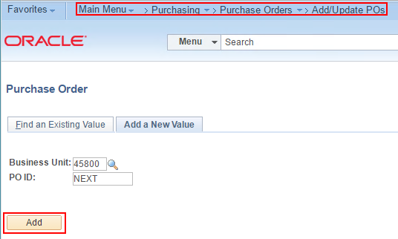
- Enter a Supplier. Select 'Requisition' in the 'Copy From' dropdown list.
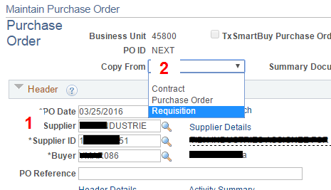
- Enter the Requisition ID and click Search.
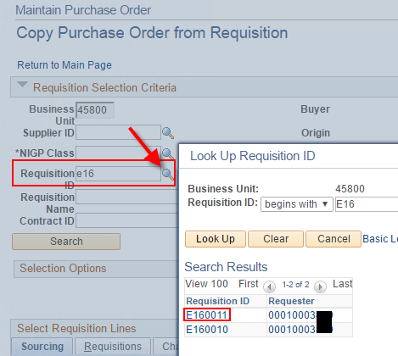
- Select the req line and click Copy To PO.
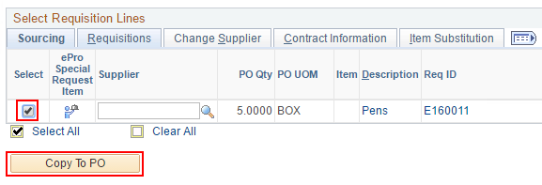
- Click the HUB Bid Details link and select 'No' in the 'Competitive?' dropdown. Click OK.
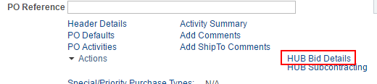 
- Go to the Class/Item tab. Click the NIGP Class search button.
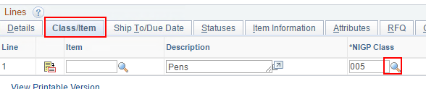
- Change the 'NIGP Complete Description' operator to 'contains' and enter 'Pens'.
Click 'Look Up'. Select NIGP Class 620.
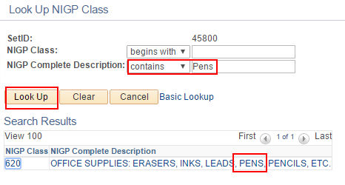
- Select 80 in the NIGP Items search list.
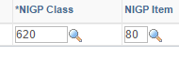
- Enter the PM & PCC.
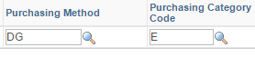
- Save the PO.

- Notice the Budget Status and Doc Tol Status are both 'Not Checked'.
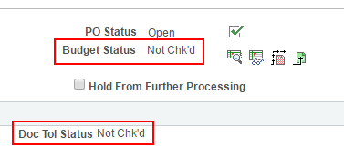
- Approve and Budget Check the PO.
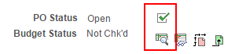
- Notice the Doc Tol Status automatically went to 'Valid' without having to manually run the Doc Tol Status process. It ran automatically when you budget checked the PO.
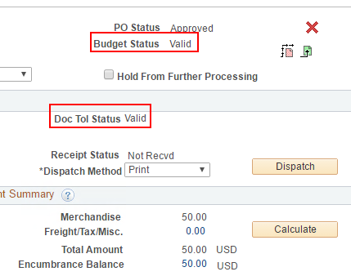
- What is the difference between Budget Checking and Doc Tolerance at this point?
---The PO budget checking process did not look to the budget to find funds. The funds were removed from the remaining balance in the budget back when the requisition was successfully budget checked.
---The PO budget checking process simply moved the pre-encumbered funds (Requisition) to the encumbrance column of the budget (Purchase Order).
---Pre-encumbrance became 0.00. Encumbrance became 50.00. Remaining budget balance unchanged.
---The Doc Tolerance, on the other hand, didn't care about the budget. It only checked to make sure the amount on the PO wasn't more than the amount on the Requisition, or if it was more, that it wasn’t too much more. How much is too much? More than the pre-set Req-to-PO tolerance.

- If you have security to access the DocumentTolerance Definition page you can see the Req to PO tolerance.
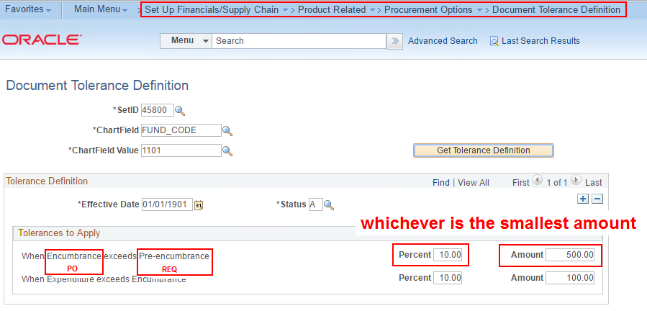
- The req line for pens is $50.00.
Percent: 10.00 tolerance would allow the PO Line to be increased $5 to $55.00.
This is less than the Amount: 500.00 tolerance, therefore the Percent tolerance wins and $55.00 is the most the line can be and still pass doc tolerance checking.
If the item being purchased was $1 million on the req, then 10% would be $100,000. In this case, Amount: 500.00 is less and therefore the most the PO Line could be and still pass doc tol would be $500 more than the req, not $100,000. The lowest ceiling is where the price increase bumps its head.
- Increase the Price on the PO to $12.00.
| 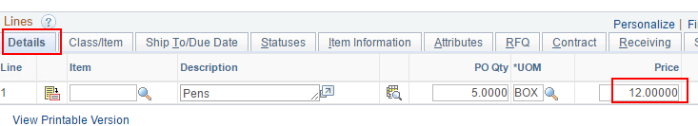

- Save the PO and notice two things:
- the Budget Status and Doc Tol Status both flip back to Not Chk'd; and
- the PO is now $60, but the extra $10 has not been encumbered yet.
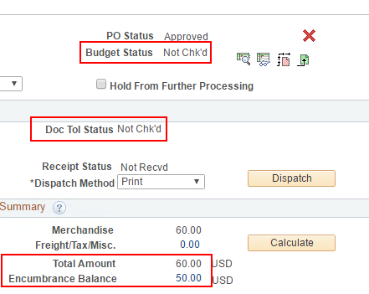

- Get the PO back into Approved status if necessary, and run Budget checking.
- Mixed result. Budget check passed. Doc Tol failed.
-Budget checking passed by finding an available $10 in the remaining balance of the budget. Recall the req was already fully liquidated.
-Doc Tolerance failed because the PO Amount is more than 10% higher than the Req Amount.
( For the fund being used on this PO Line, the tolerance is set to the lesser of 10% or $500. $5 is less than $500. )
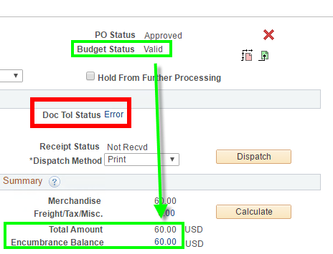
- Click the word 'Error' which is a hyperlink.
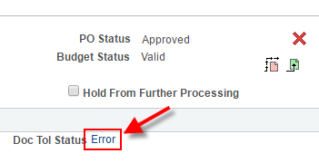

- If you have security to override Doc Tol Exceptions, and if you have permission under your business process guidelines to override on this particular order, then you can check the Override box and click Save.
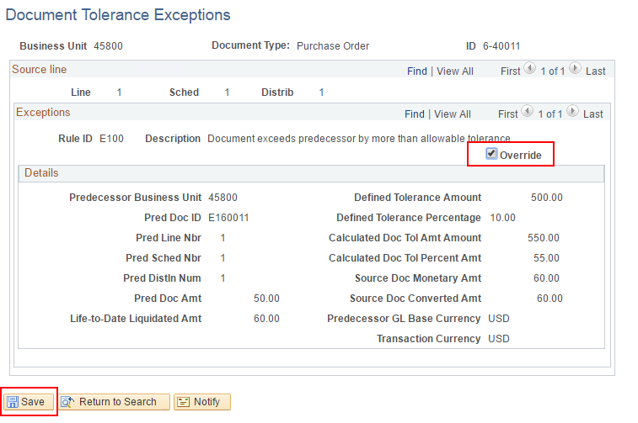
- Navigate back to the purchase order and notice the Doc Tol is now Valid.
[Note: some browsers may have opened a second window in the previous step, leaving your PO window open. If that's the case you'll need to release the PO from your screen by clicking the 'Return to Search' button and bring it back up fresh to see that the Doc Tol is now valid.]
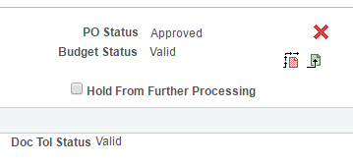

- Increase the price another penny to $12.01. Save. Budget Check.
Notice that overriding the Doc Tolerance once is not a lifetime override. This extra nickel requires another override. This reminds the Purchaser that he or she is operating above the amount approved on the requisition.
