Asset Addition – Basic Add
- Navigate to: Main Menu > Asset Management > Asset Transactions > Owned Assets > Basic Add

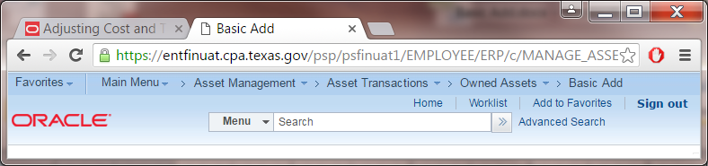
- Click on the Add a New Value tab. Enter Business Unit and an Asset Identification (as asset tag number). Click Add.
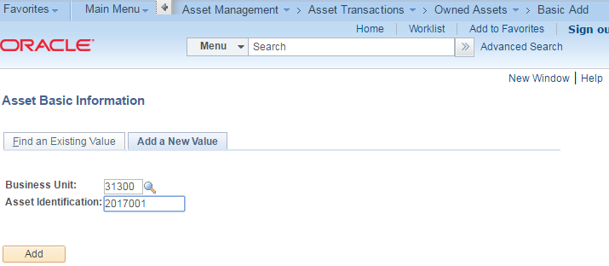

- On the General Information tab, select a Profile Id. The asset profile ID populates the Asset Class, Description and Asset Type. Each asset Acquisition Code defaults to “State Sources”. Select the appropriate value from the drop down list.
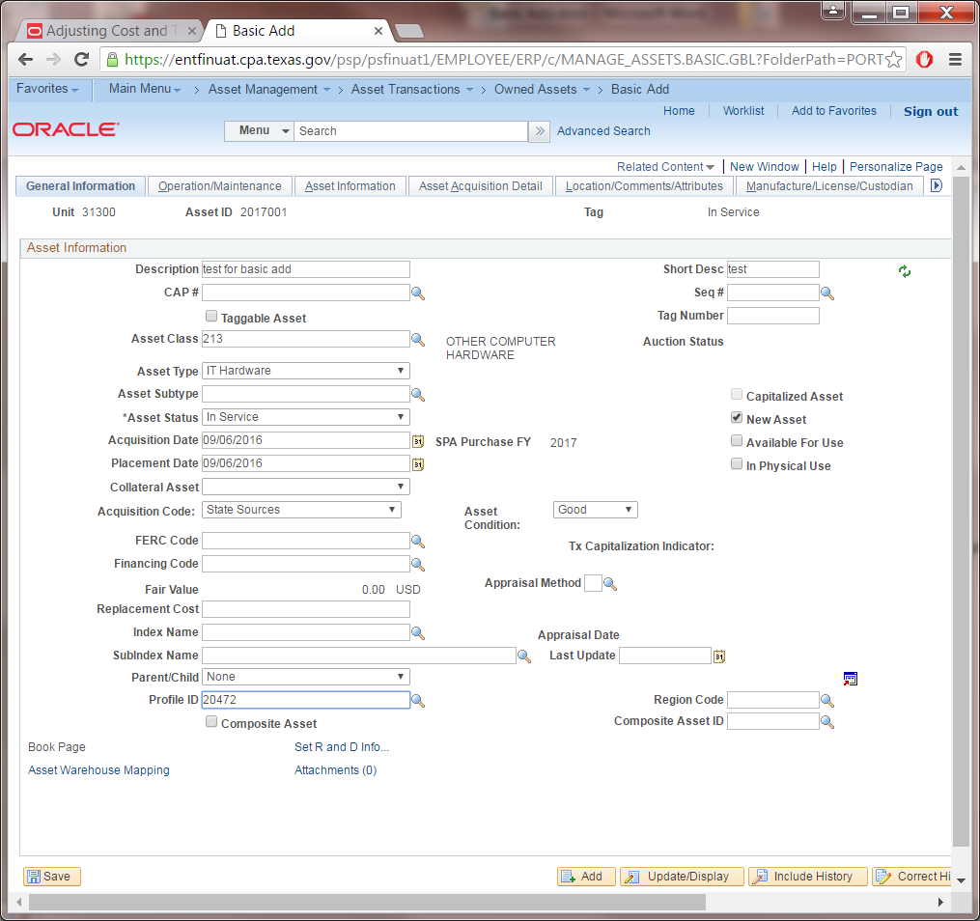
- Navigate to Asset Information tab to enter Serial ID, Location code of the asset and Custodian information.
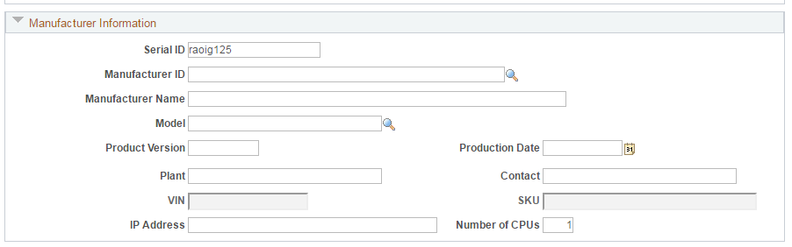
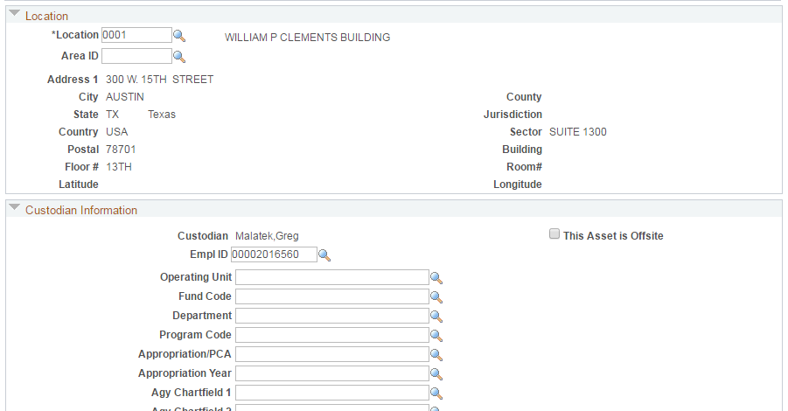

- Click the Asset Acquisition Detail tab. Enter the cost of the asset in the Amount field. Click on the Acquisition Detail Chartfields link and enter the Fund, Appropriation Year and other required chartfields values. Click the OK button.

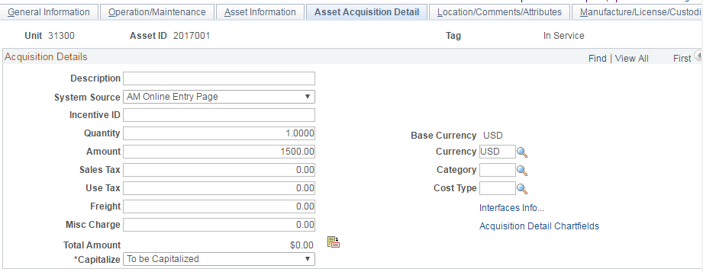
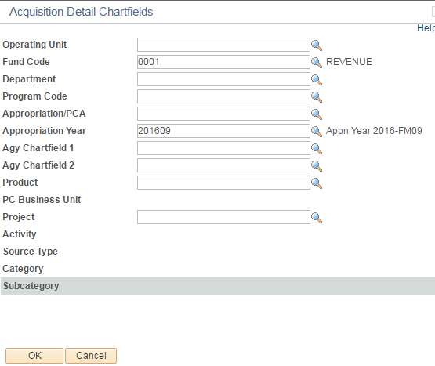

- Click the Capitalize button and verify values entered.
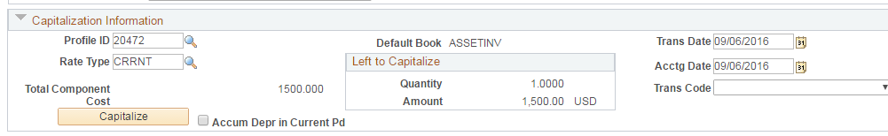

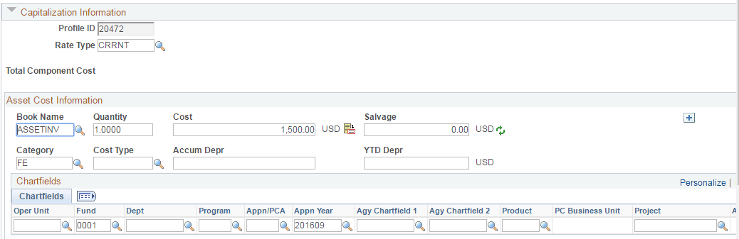
- Click the Save button at the bottom left of the page to save the asset.
