PO –Amount Only
- Use Amount Only to allow receiving partial dollar amounts against a PO Line.
- Use Amount Only to allow multiple payments against a PO Qty of 1, e.g. blanket POs.
- The Attributes tab on each PO Line contains an Amount Only checkbox.
If this checkbox was checked on the Requisition Line, then it is already checked on the PO Line.
If not, the buyer can check the box on one or more PO Lines.
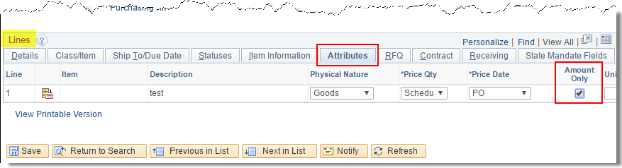
- The PO Qty field must be 1 to use Amount Only. If quantity is not 1 already, it will change automatically when Amount Only is checked, requiring you to manually change the price accordingly.
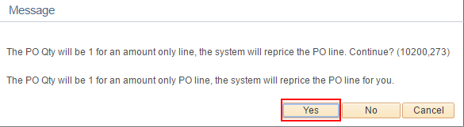

- Using Amount Only allows the services being purchased on the PO Line to be received in partial amounts.
- In this clip from a PO Receipt, notice that the Receipt Price on Line 3 is ungrayed, i.e. able to be changed. This is only possible when the Amount Only checkbox is checked on the PO Line.
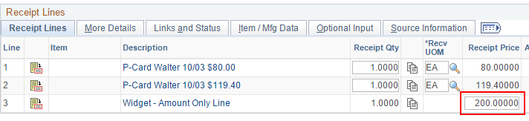\
- Another benefit of using Amount Only is the ability to enter mutliple vouchers against a PO Line that has Qty = 1 without bumping into an error due to Life to date Voucher Qty is greater than PO Qty. The Amount Only designation on the PO Line communicates to the voucher that we're not concerned about quantity, only amount.
- If you want the Requester to designate certain req lines as Amount Only so that it defaults into the PO already checked, the Requester will find the checkbox on the Requisition Line Details page.
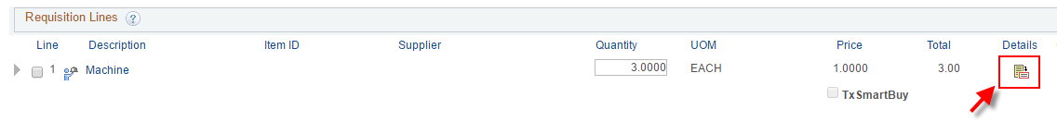
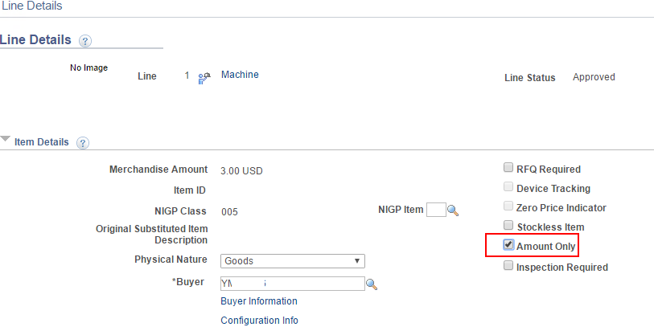
- If you want the Buyer to be reminded to check Amount Only for certain types of purchases such as Services, this can be set for each NIGP Class.
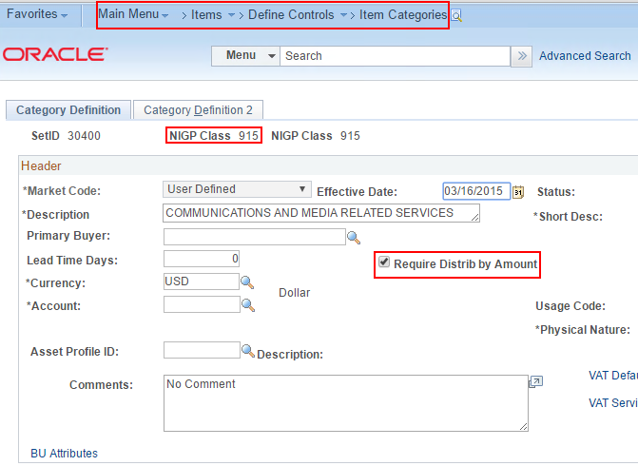
- When the Buyer saves a PO that contains an NIGP Class flagged as 'Require Distrib by Amount', a warning message will appear. It is a warning only.
